**Deploy a PHP application using Windows IIS Web Server**

To perform this tutorial you will require a computer installed with Windows Server/11/10. Make sure the computer is assigned with an IP address.

1. **Install IIS web server with CGI support.**

To run a PHP based application, IIS web server requires Common Gateway Interface (CGI) support enabled.

To install IIS web server on **Windows Server** use following steps.

Login as administrator user. In the server manager click Manage and select Add Roles and Features.

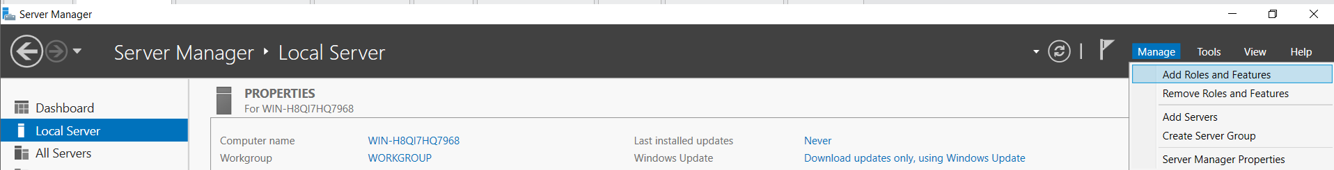

Add Roles and Features Wizard will start as shown below.

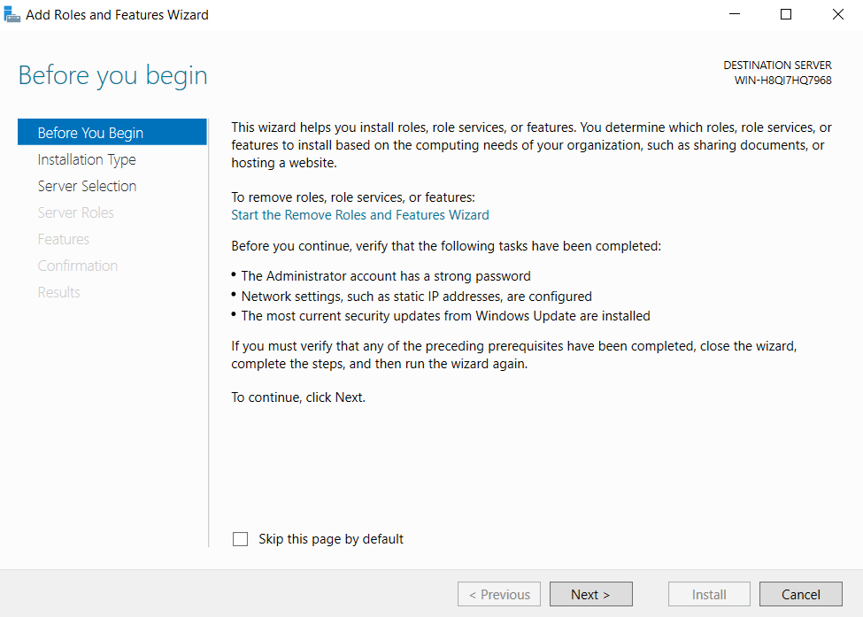

Click Next till you get the following screen.

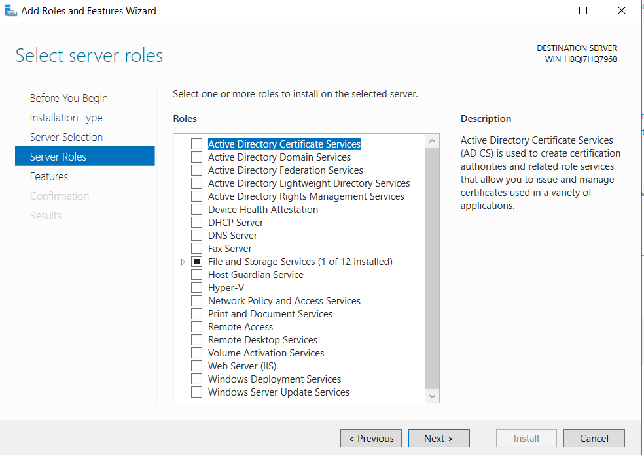

In the above Screen select the check box of Web Server (IIS). It will open a screen as shown below.

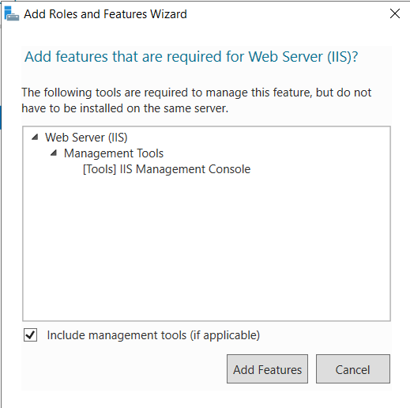

Click Add Features.

This is how the Web Server (IIS) role is selected for installation as shown below.

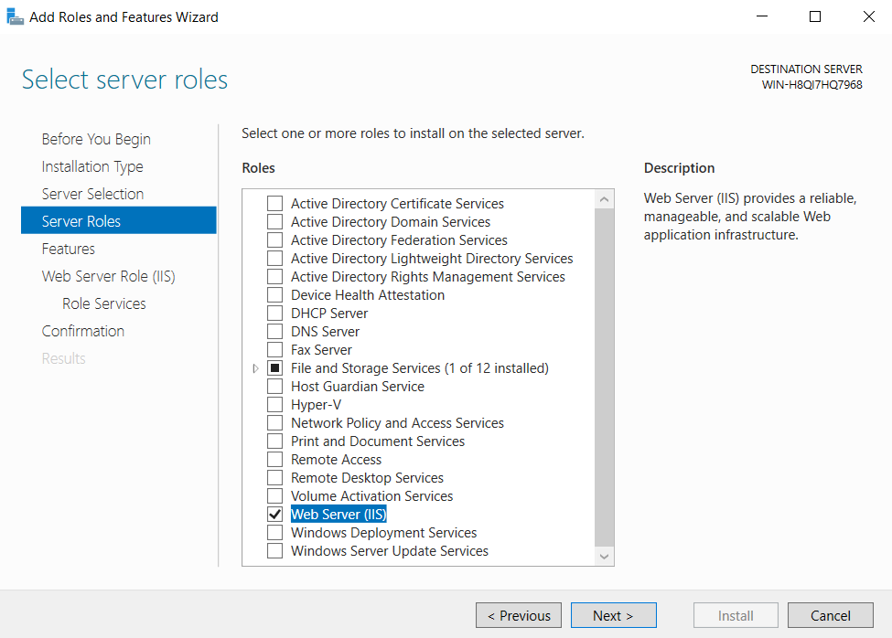

Click Next on all screens till you come to the following screen.

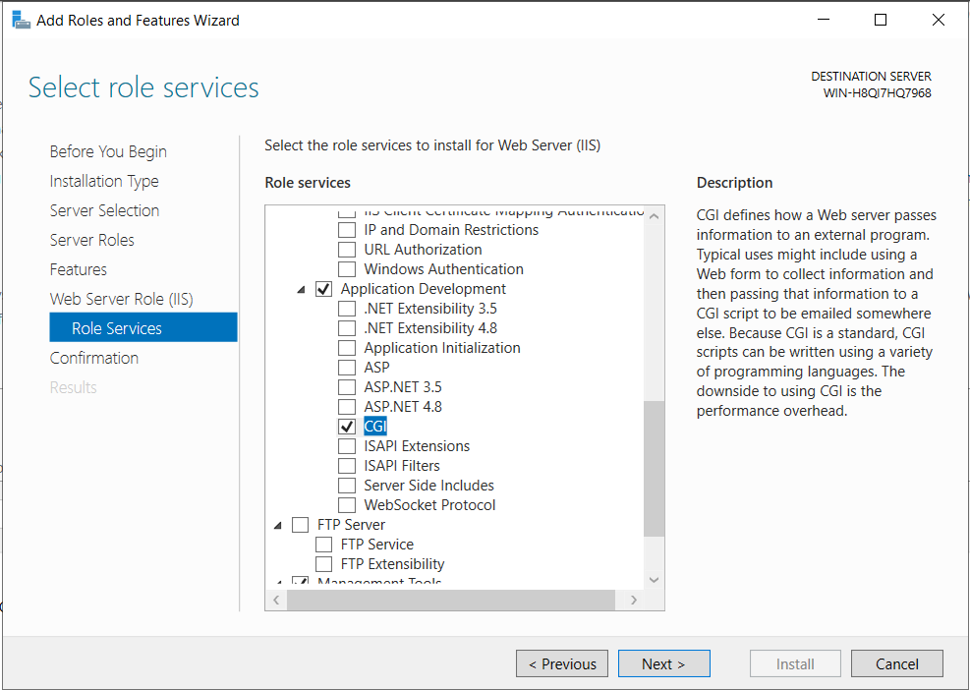

In the above screen scroll down and find the Application Development Section. Click > this sign to expand the section. Below this section select the check box of CGI as shown above.

Click Next. Click Install on the final screen. Close the window once installation is complete. This is how the Web Server (IIS) is installed.

**Follow these steps only if you are using Windows 11 or Windows 10.**

Install IIS Web Server on Windows 10/11.

Login with a user having administrator permissions. In the Search field type Turn Windows and it will show the result as below.

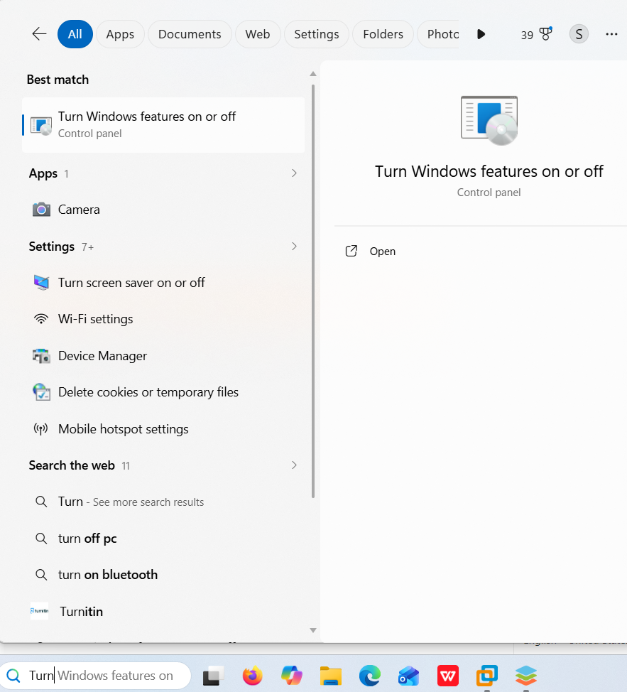

Click on it open. The following Window opens.

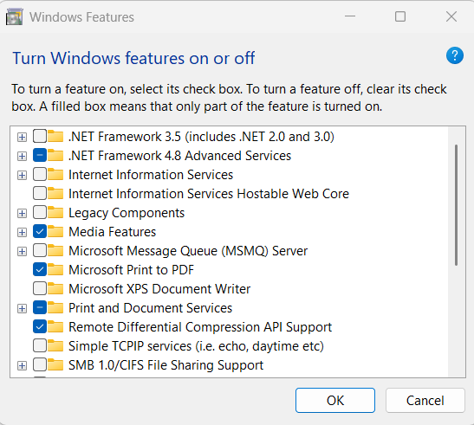

Select the check box of Internet Information Services. Click OK to Install IIS.

**2.** **Install PHP for Windows**

Open the browser and go to the <https://windows.php.net/> website.

Once the website opens scroll the page and look for the following section on the left side of the web page.

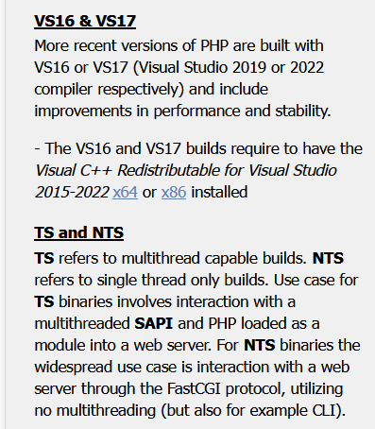

The version VS16 and VS17 may change. Below it there is X64 written in blue colour. Click it to download the following file.



These are the C++ libraries required by the PHP. Once the file downloads, double click to install it.

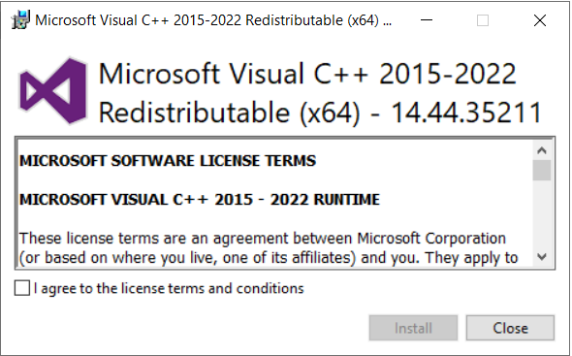

Select the check box of I agree to the license terms and conditions and click Install.

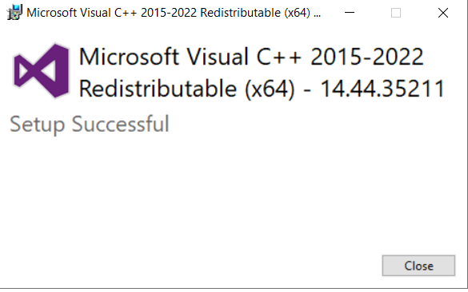

Close the Window. If it asks you to restart the computer then restart the computer before you go to the next step.

Now download the PHP zip file.

On the same website click Downloads option.

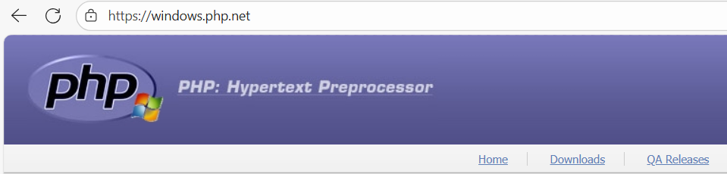

Or go to the [https://windows.php.net/download/](https://windows.php.net/downloads/)

On the download page look for the Non Thread Safe version of PHP and download the ZIP file.

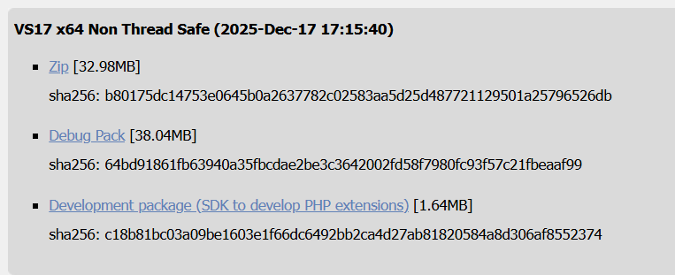

Once the Zip file downloads, go to the downloads folder. Double click on the zip file. Press Ctrl and a button to select all files. This is as shown below.

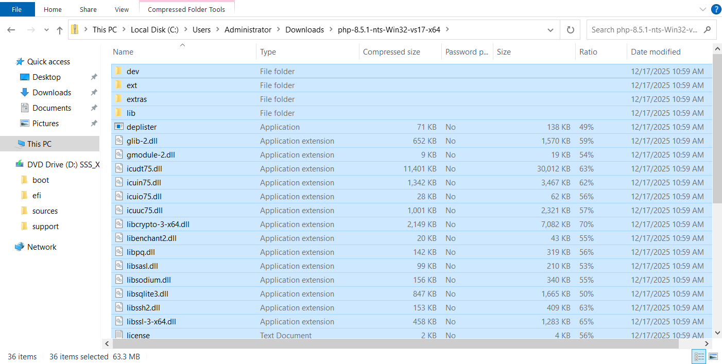

Now press Ctrl and c to copy the files or right click and select copy. A warning may be shown saying “copying these files may harm your computer”. Click OK.

Now click This PC option in the same window. Double click C:. Then right click and create a new folder and name it as php. This is as shown below.

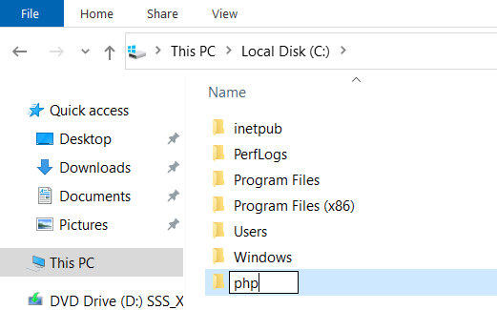

Once the folder is created then doble click the php folder to go inside. Now press Ctrl and v or right click and select paste all the files into this folder.

This is how you have to copy all the files inside the PHP zip file to the php folder on the C drive.

Now right click on the This PC option.

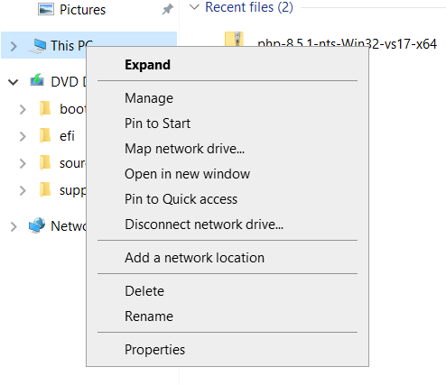

Click Properties option. On the screen that opens, look for the Advanced System Settings option. You may have to scroll down to get this option.

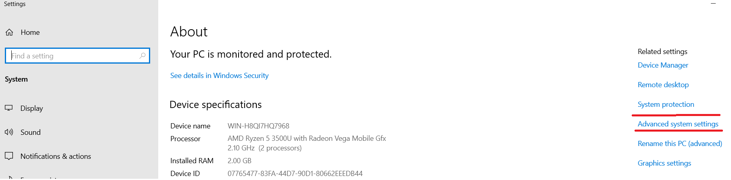

Once you click the Advanced System Settings, following screen opens.

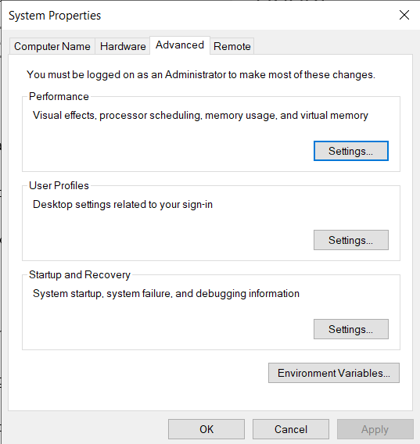

Click Environmental Variables option. The following Screen will open.

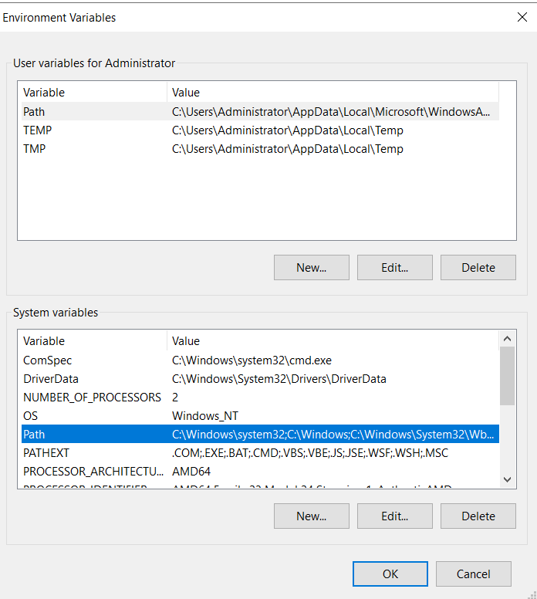

In the System Variables section select Path. Then Click Edit button just above the OK button.

On the new screen that opens, Click New button and type c:\php as shown below.

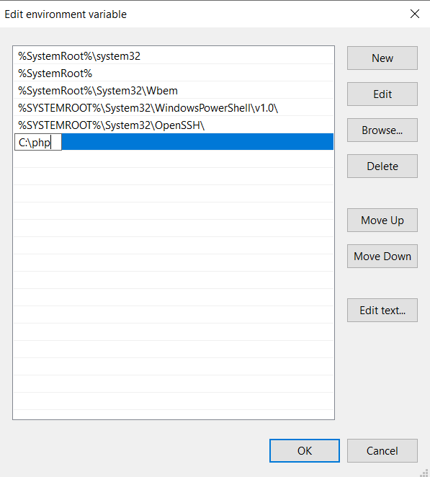

Click OK.

Click OK on all screens to close them.

Now in the Search field type cmd.

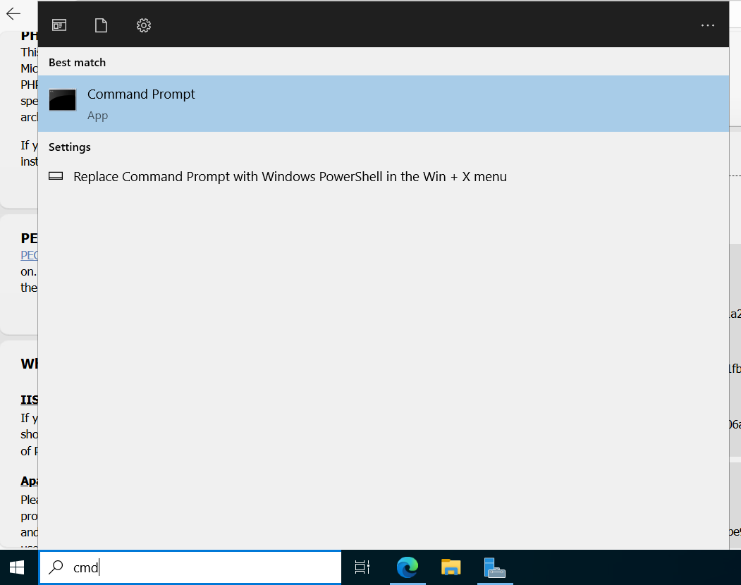

Click Command Prompt to open Windows Command Prompt.

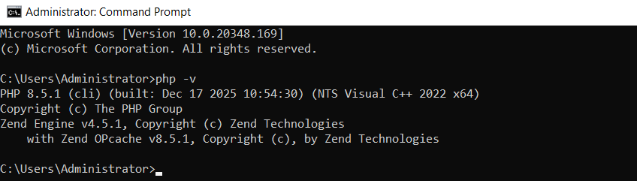

In the command prompt type command **php –v** . You should get the output as shown above. The version may be different. Close the command prompt.

Now configure PHP to work with SQL database.

Go to C:\php directory.

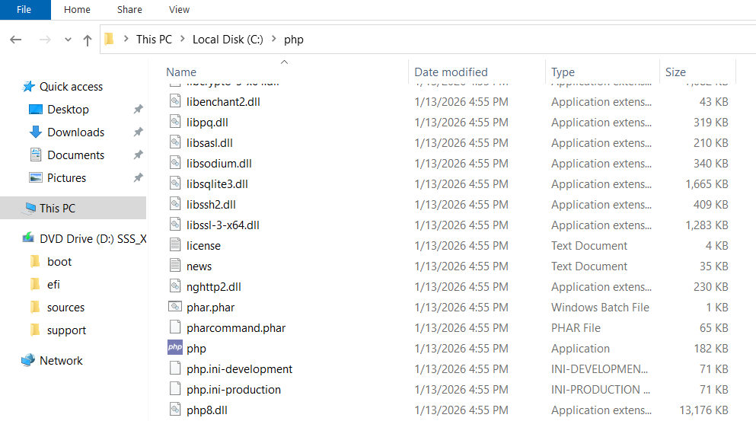

Scroll down. You will find 2 files by name php.ini-development and php.ini-production. This is shown in the above image (last 3 lines).

Rename the php.ini-production file to only php.ini (remove production from the name).

Now the file will be shown only by name php. This is because Windows does not show the file extensions. The file will show configuration settings in the type in front of file name.

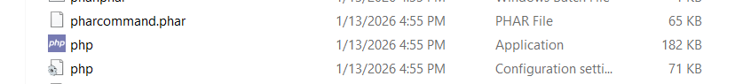

Right click on this file and select Edit option. The file will open and display following contents.

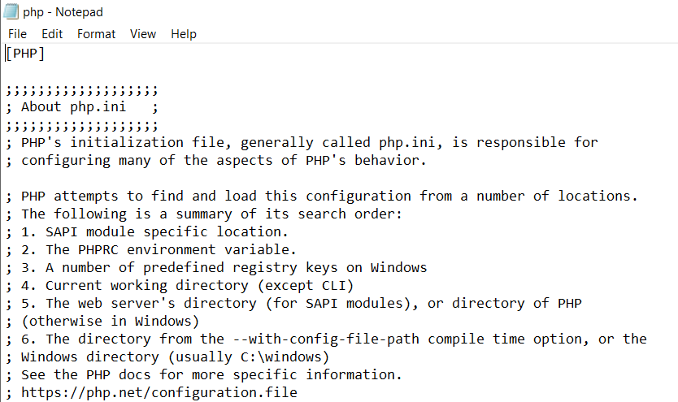

In the Notepad Click Edit option.

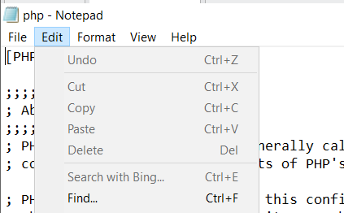

Click Find option.

In the search field type **fastcgi.impersonate** to search in the file**.**

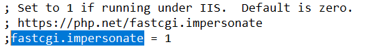

Remove the semicolon before this line.

Now remove earlier search words and type mysqli to search and click find next. Click Find Next button till you reach the following section in the file.

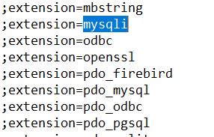

Remove the semi colon before the line **extension=mysqli** and **extension=pdo_mysql**

Save the file.

This is how you have installed and configured PHP on Windows computer.

Now in the next step you will install MySQL server.

**3. Install MySQL database server.**

Next step is to install the MySQL database server.

Open the browser and go to the URL <https://dev.mysql.com/downloads/>

On the Downloads web page click **MySQL Community Server** option.

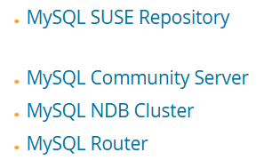

On the web page that opens click Download button in front of Windows MSI iinstaller as shown below. The version may be different.

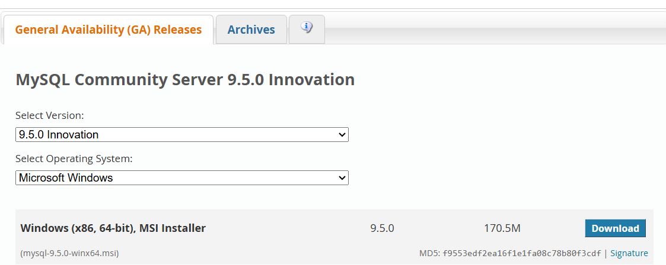

Following page is displayed.

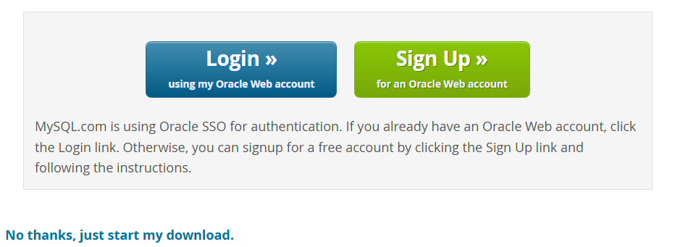

Click No thanks, just start my download option.

Once the download completes, click the MySQL installer file. Following screen opens.

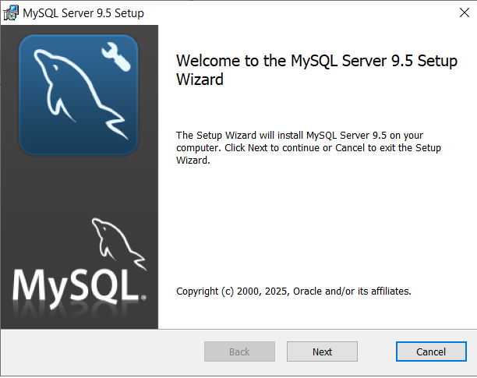

Click Next.

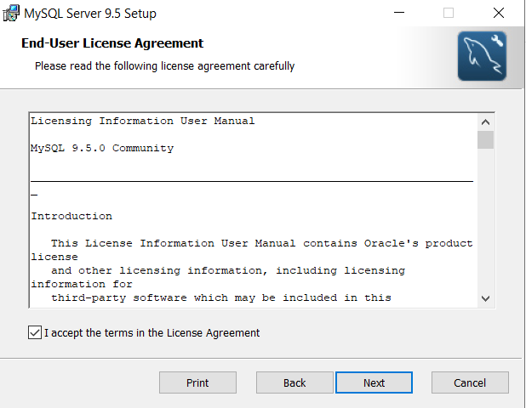

Select Check box I accept the terms in the License Agreement. Click Next.

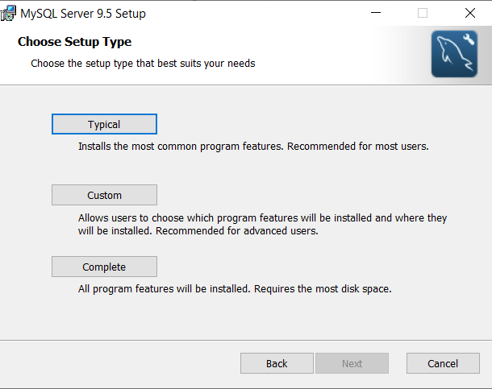

On the next screen, click Typical.

Click Install.

Once the installation completes, following screen is displayed.

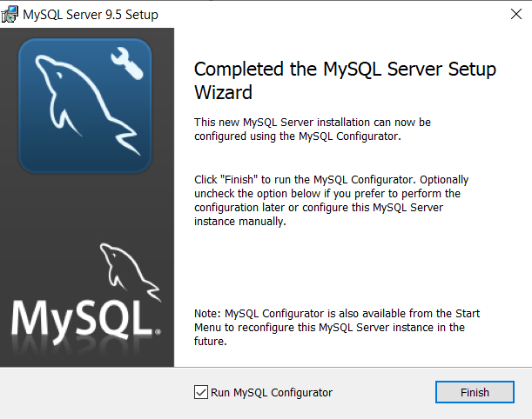

Click Finish. It will start the MySQL configuration wizard.

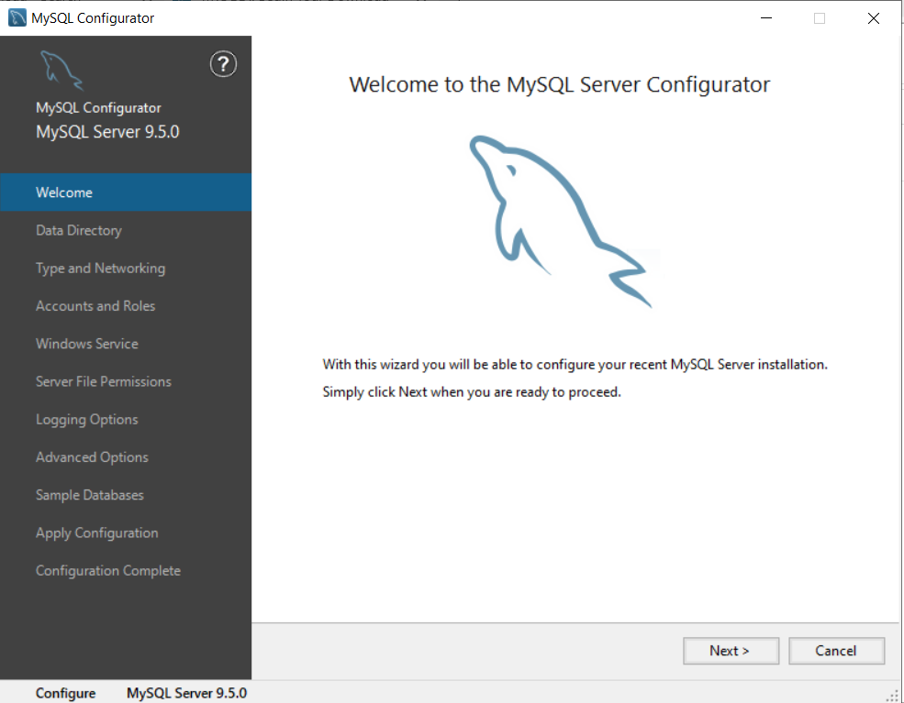

Click Next.

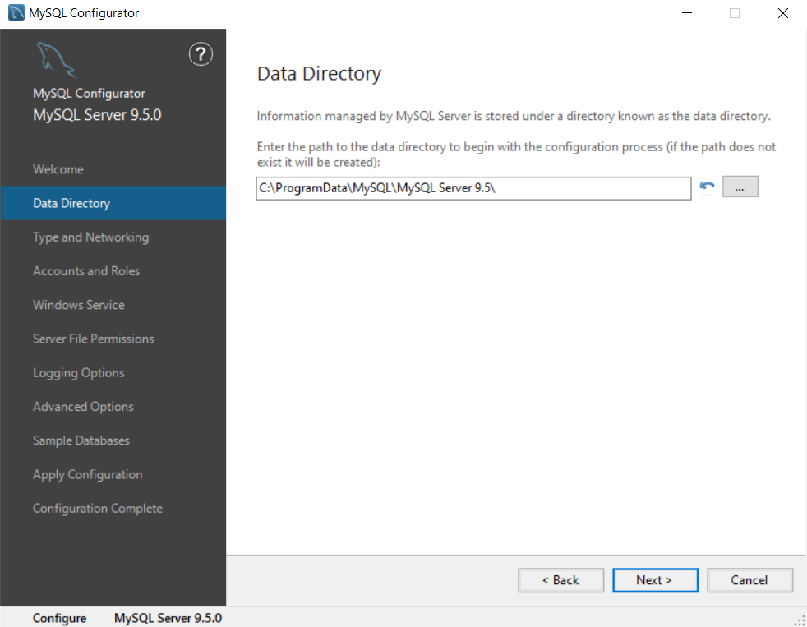

Click Next to keep the default installation directory.

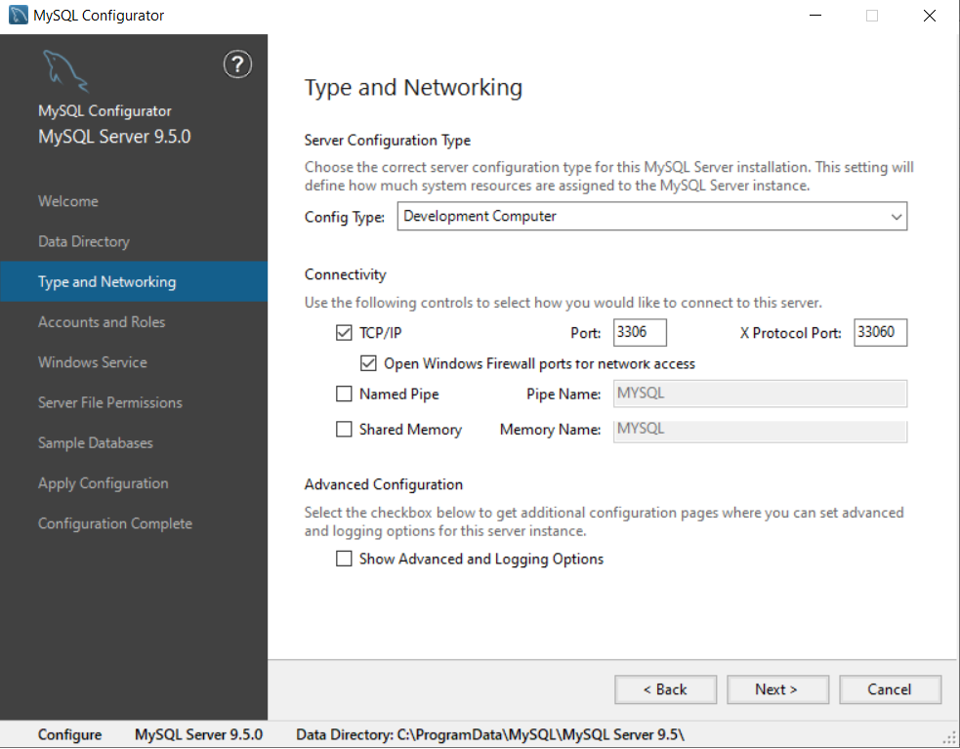

Click Next on the above screen to keep the default options and the TCP ports for MySQL server.

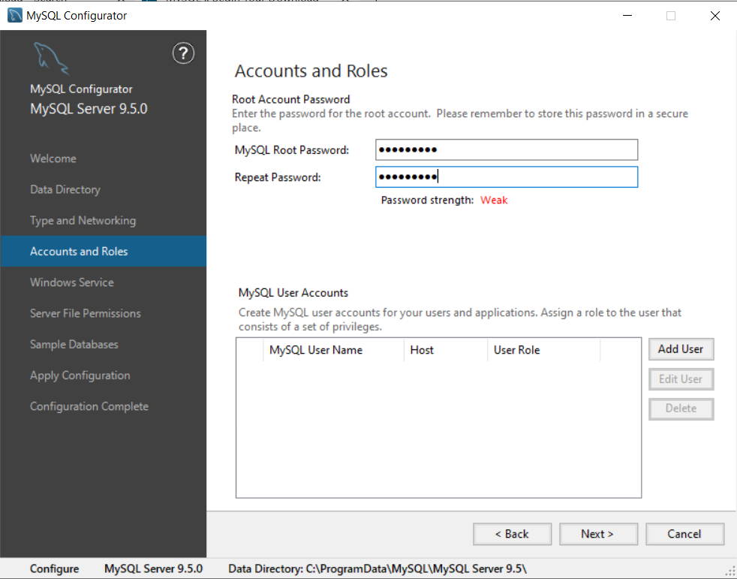

On the above screen, type a password for the MySQL root user. Note down the given password as it is required later.

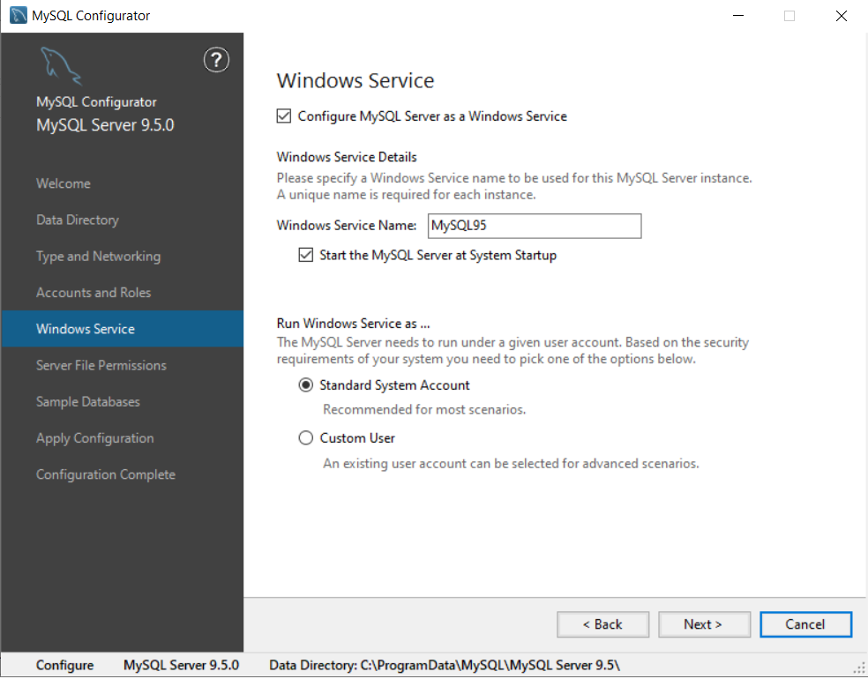

Click Next on the above screen to keep default options.

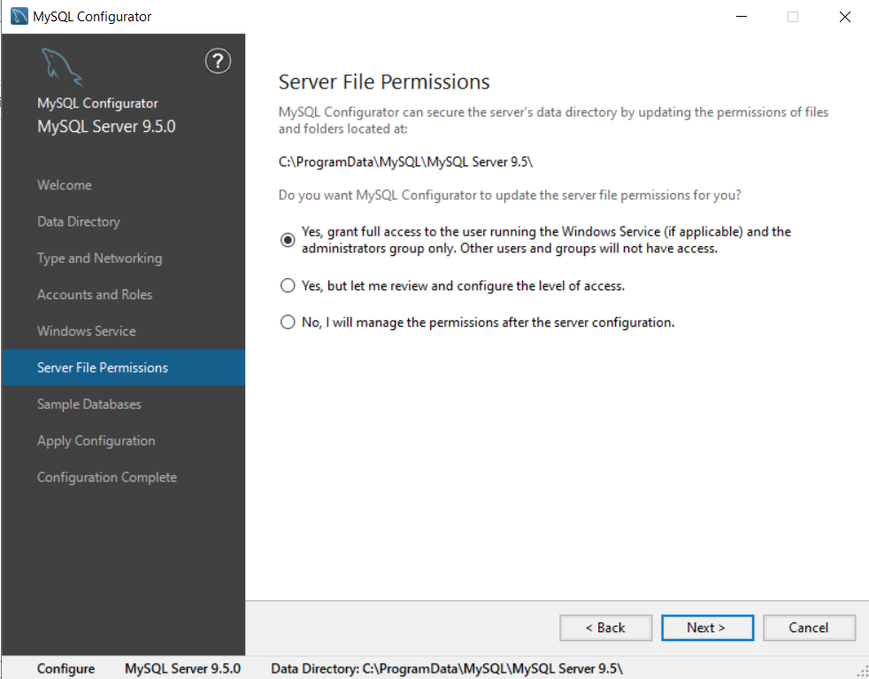

Click Next on the above screen.

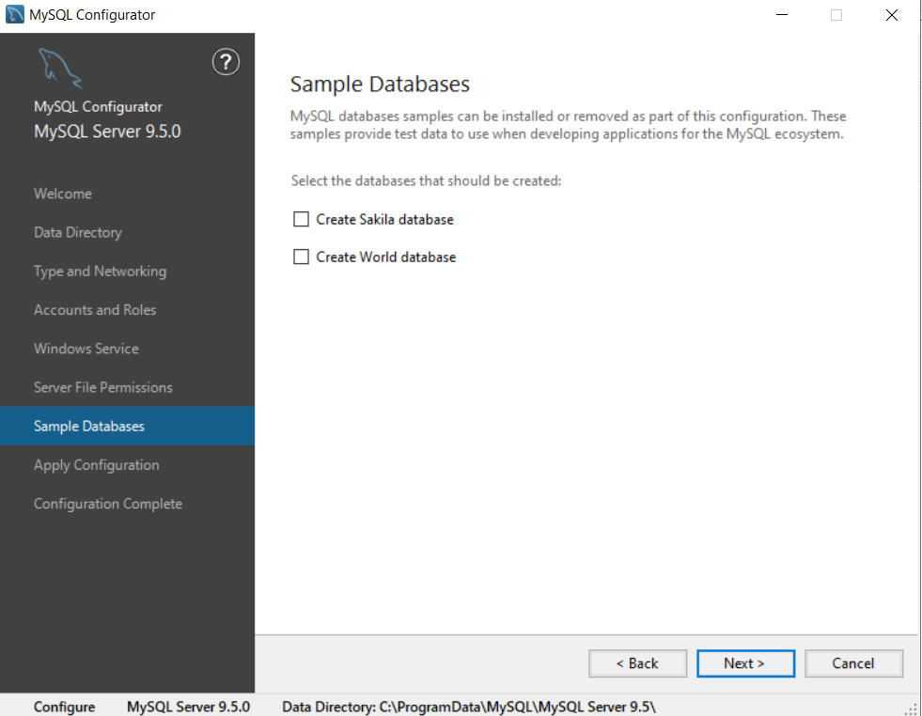

Do not select any check box. Click Next.

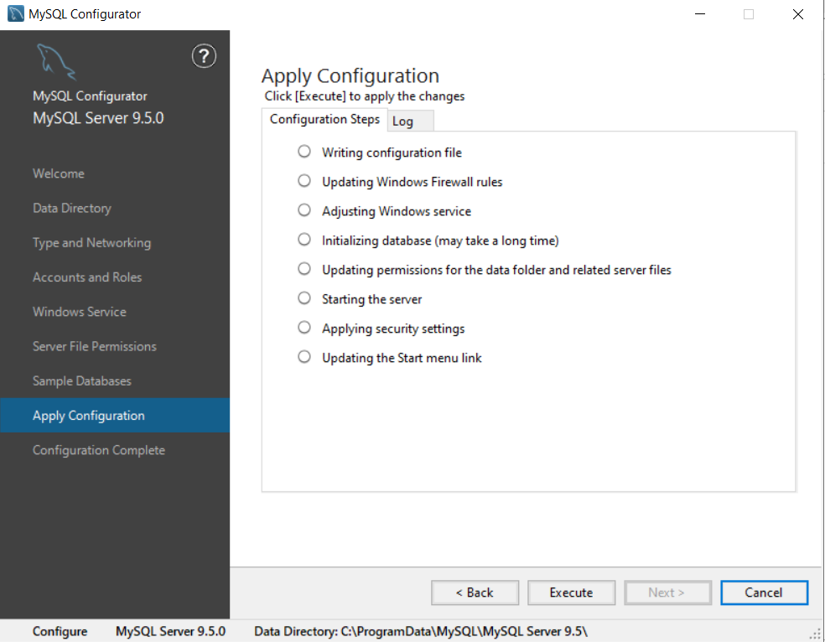

Finally Click Execute to configure and start MySQL server.

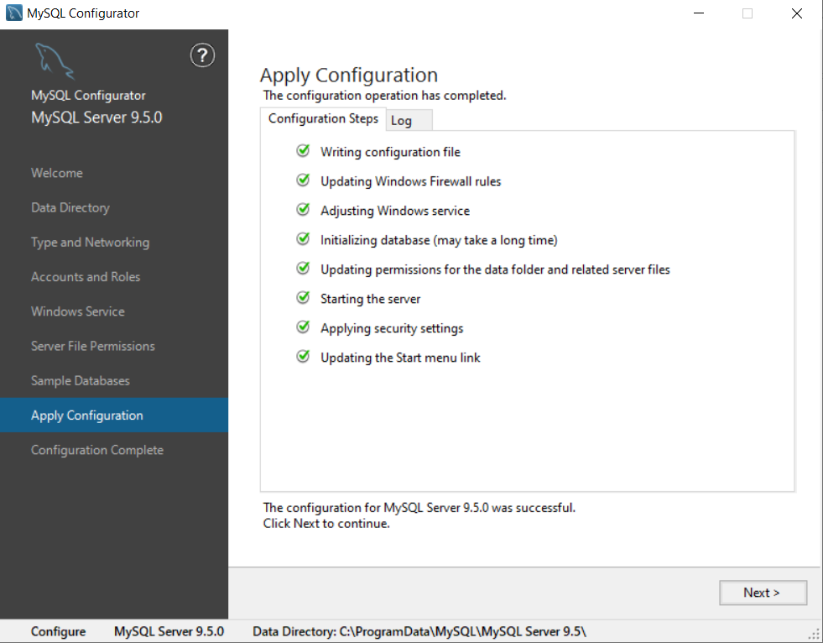

Once the configuration is successful, click Next.

Click Finish to close the Window.

This is how you have installed the MySQL server.

**4. Configure IIS to host PHP web application.**

In the Server Manager click Tools. Then click Internet Information Services (IIS) Manager option as shown below.

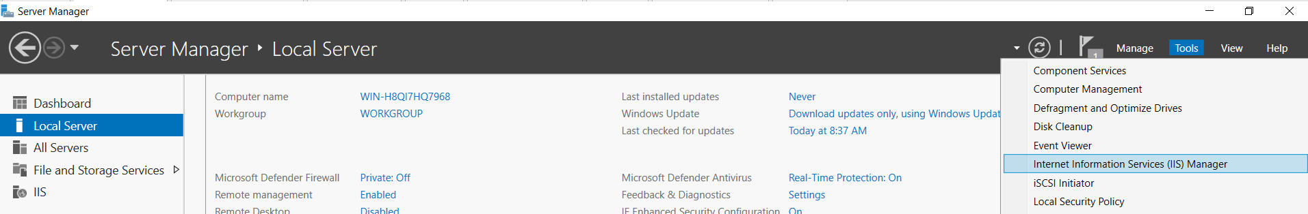

This will open a Window as shown below.

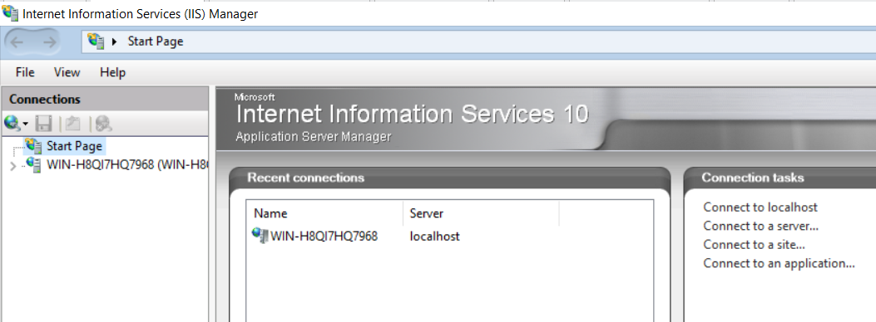

Now click the server name shown below Start page option on the left side.

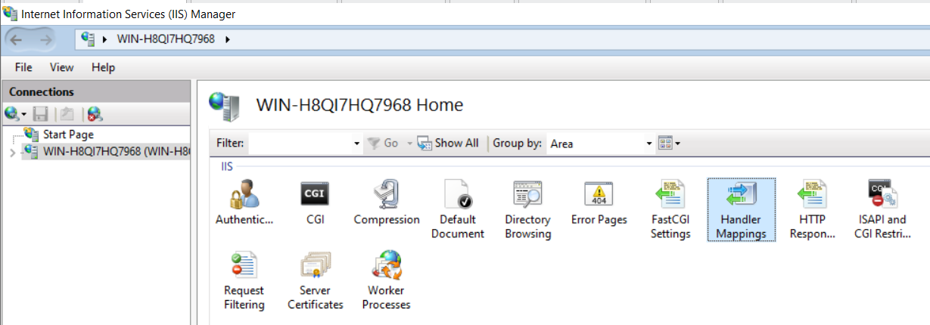

Double click the Handler Mappings option as shown above.

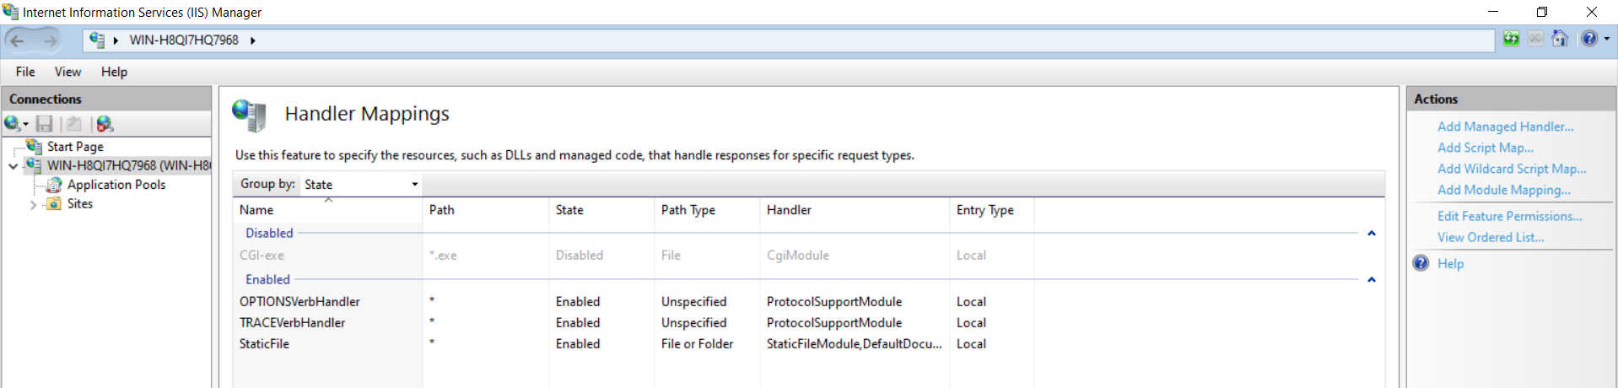

The above Screen is displayed. On the right hand side you will find Add Module mapping option (in Blue color).

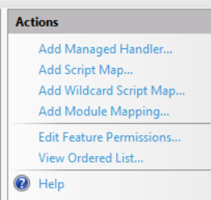

Click that option.

The following Window opens. In this in the Request path field type *.php.

In the Modules field click drop down arrow and select FastCgiModule option.

Click the three dots in the executable section. Go to the C:\php directory and select php-cgi.exe file.

It should look like as shown below.

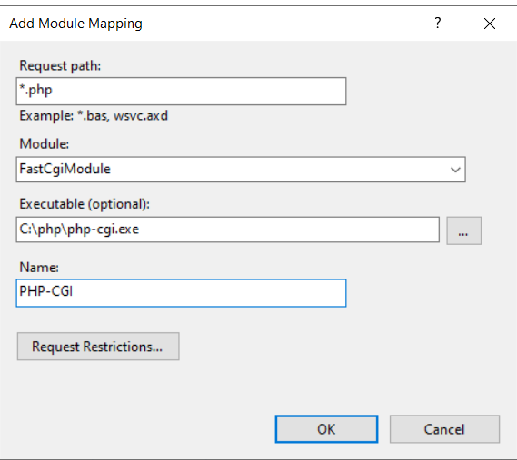

In the Name field type any name like PHP-CGI.

Then click the Request Restrictions button. Following Screen is displayed.

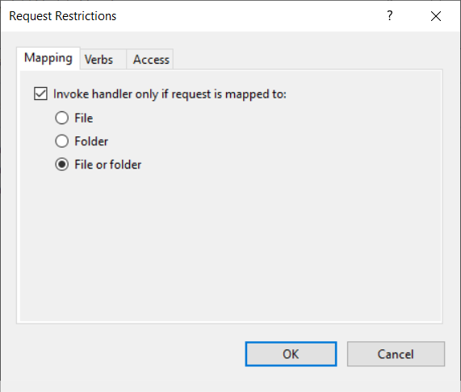

Select File and folder. Click OK.

Click OK on the Add Module Mapping screen.

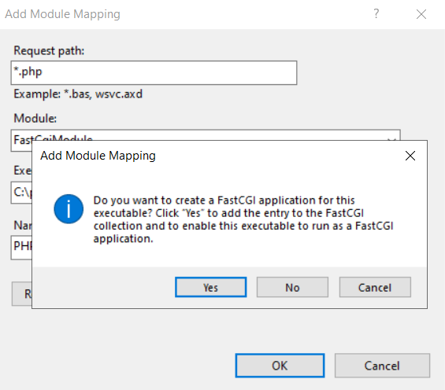

Click Yes. An entry will be created as shown below.

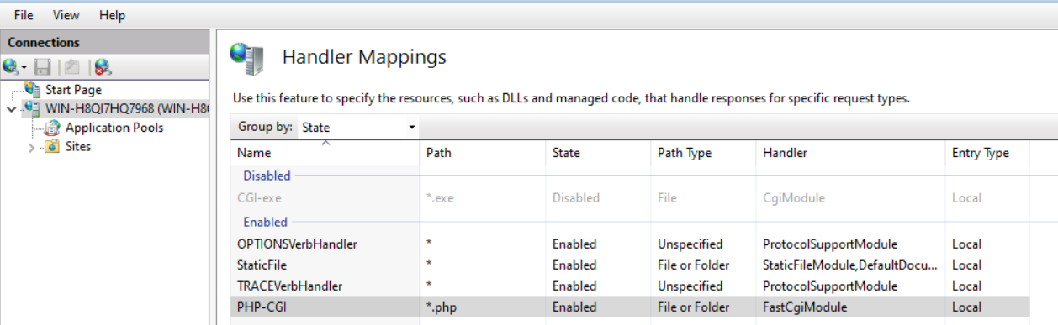

Now again click the server name on the left side and select Default Document option.

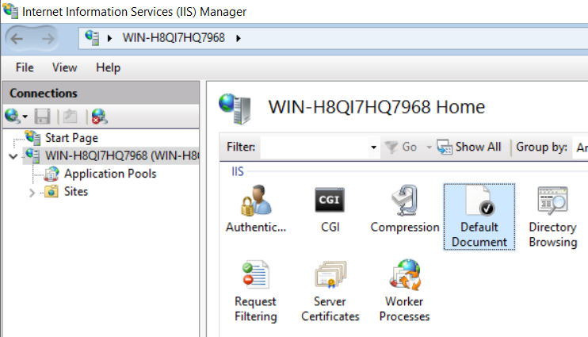

Double click the Default Document option.

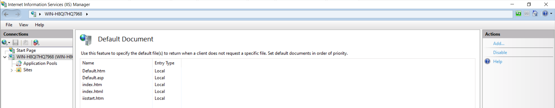

In the above screen click Add on the right hand side (in blue color text).

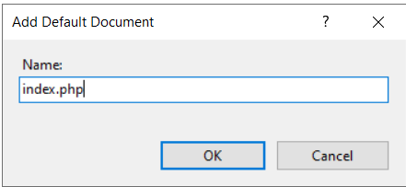

Type index.php and Click OK.

**5. Download and configure phpmyadmin**

Phpmyadmin is a web based software written in PHP. This software allows you to connect to MySQL server and create new database, tables or manage existing databases.

Open browser and go to the URL <https://www.phpmyadmin.net/>

Following web page opens.

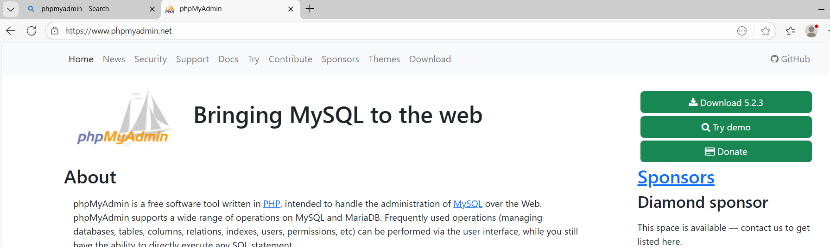

Click the Download button. The version may be different.

A donate to phpmyadmin page may open. Do not click on that page. Download will start in the background. It may take a bit of time after downloading entire bytes.

Go to the downloads folder once the download is complete. Double click the phpmyadmin zip file. You will see a folder by phpmyadmin and its version.

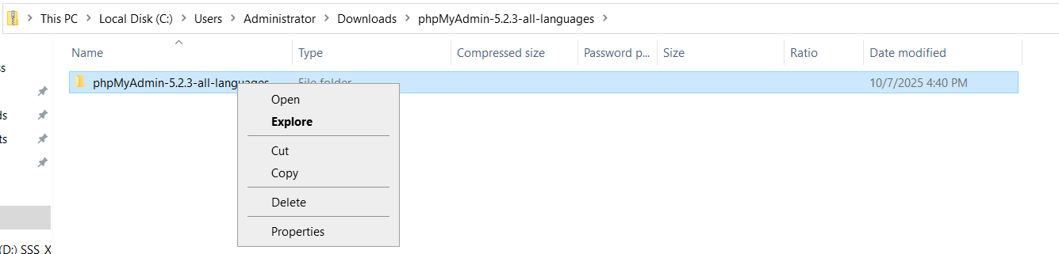

Right click and select copy.

Now go to the C:\inetpub\wwwroot directory and paste it. It should be like as below.

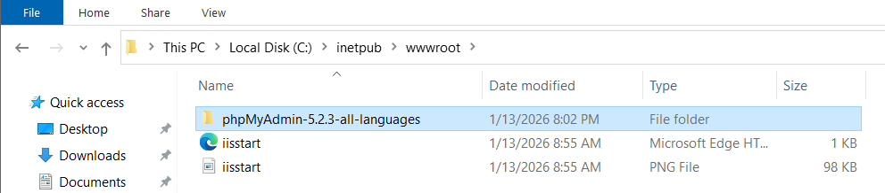

Now rename this folder to phpmyadmin.

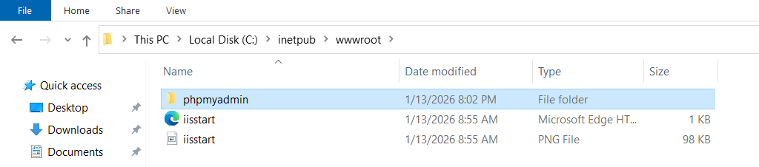

Now open the browser and type <http://localhost/phpmyadmin>

The following web page will be displayed.

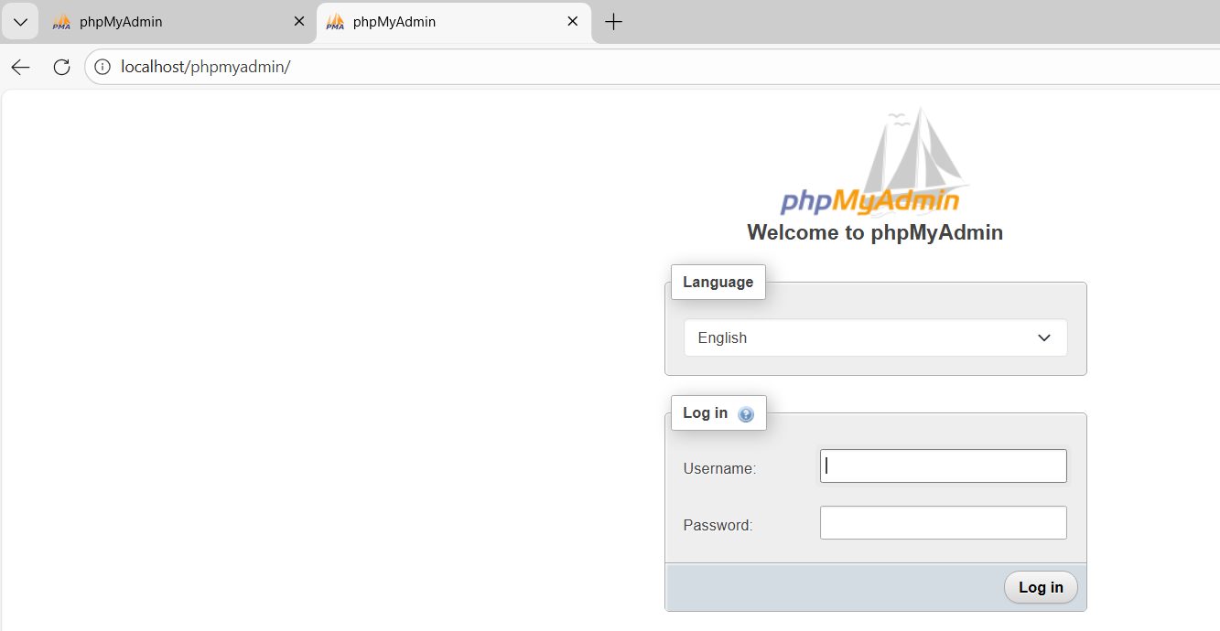

Now type **root** as the username. In the password field type password that you entered above while installing MySQL server.

The following web page should open.

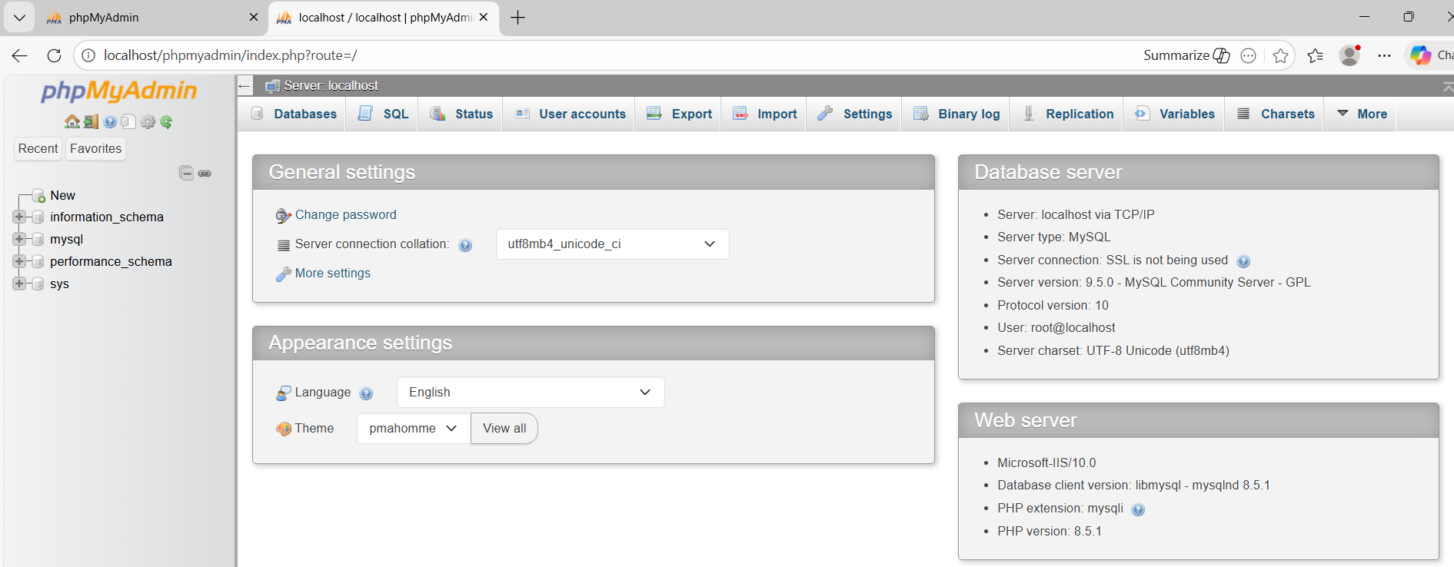

**6. Prepare a PHP application**

Here you will develop a simple PHP web application that will provide a home page (index.php) that will give an option to register and Login. On registration page users can register. That will create there login ID in the database. After Login user will get a welcome page which will allow user to upload a file.

Go to the c:\inetpub\wwwroot directory.

Right click and select New Text Document option. Give the name to the file as **index.php.** Double click on the file to open it. Copy following code and paste into this file.

############ index.php###############

<!DOCTYPE html>

<html lang="en">

<head>

<meta charset="UTF-8">

<meta name="viewport" content="width=device-width, initial-scale=1.0">

<title>Horizon Institute of Technology</title>

<style>

body { font-family: Arial, sans-serif; line-height: 1.6; margin: 0; padding: 0; text-align: center; }

header { background: #2c3e50; color: white; padding: 2rem; }

.container { padding: 3rem; }

.btn {

display: inline-block;

background: #3498db;

color: white;

padding: 10px 20px;

text-decoration: none;

border-radius: 5px;

margin: 10px;

}

.btn-secondary { background: #95a5a6; }

.btn:hover { opacity: 0.8; }

</style>

</head>

<body>

<header>

<h1>Horizon Institute of Technology</h1>

<p>Empowering Minds, Shaping Futures</p>

</header>

<div class="container">

<h2>Welcome to the Student Portal</h2>

<p>Please register to create an account or login to access your file management dashboard.</p>

<div class="navigation">

<a href="register.php" class="btn">New Student Registration</a>

<a href="login.php" class="btn btn-secondary">Student Login</a>

</div>

</div>

<footer>

<p>&copy; 2024 Horizon Institute of Technology. All rights reserved.</p>

</footer>

</body>

</html>

Save the file.

#############login.php##############

Next similarly create a file by name **login.php**. Add following contents to it.

<?php

require 'db.php';

session_start();

if ($_SERVER["REQUEST_METHOD"] == "POST") {

$username = $_POST['username'];

$password = $_POST['password'];

$stmt = $conn->prepare("SELECT id, password FROM users WHERE username = ?");

$stmt->bind_param("s", $username);

$stmt->execute();

$result = $stmt->get_result();

$user = $result->fetch_assoc();

if ($user && password_verify($password, $user['password'])) {

$_SESSION['user_id'] = $user['id'];

$_SESSION['username'] = $username;

header("Location: welcome.php");

} else {

echo "Invalid username or password.";

}

}

?>

<form method="POST">

<h2>Login</h2>

<input type="text" name="username" placeholder="Username" required><br>

<input type="password" name="password" placeholder="Password" required><br>

<button type="submit">Login</button>

</form>

Save the file.

###### logout.php ###########

Next create a file by name **logout.php**. Add following content to this file.

<?php

session_start();

session_destroy();

header("Location: login.php");

exit;

?>

Save the file.

############# register.php #########

Now create a file by name **register.php**. Add the following content in the file.

<?php

require 'db.php';

if ($_SERVER["REQUEST_METHOD"] == "POST") {

$username = $_POST['username'];

$password = password_hash($_POST['password'], PASSWORD_DEFAULT);

$sql = "INSERT INTO users (username, password) VALUES (?, ?)";

$stmt = $conn->prepare($sql);

$stmt->bind_param("ss", $username, $password);

if ($stmt->execute()) {

echo "Registration successful. <a href='login.php'>Login here</a>";

} else {

echo "Error: " . $stmt->error;

}

}

?>

<form method="POST">

<h2>Register</h2>

<input type="text" name="username" placeholder="Username" required><br>

<input type="password" name="password" placeholder="Password" required><br>

<button type="submit">Register</button>

</form>

Save the file.

############# welcome.php ###########

Now create a file by name **welcome.php**. Add following content to this file.

<?php

session_start();

if (!isset($_SESSION['user_id'])) {

header("Location: login.php");

exit;

}

if (isset($_FILES['my_file'])) {

$target_dir = "uploads/";

// Ensure the 'uploads' folder exists

if (!is_dir($target_dir)) mkdir($target_dir);

$target_file = $target_dir . basename($_FILES["my_file"]["name"]);

if (move_uploaded_file($_FILES["my_file"]["tmp_name"], $target_file)) {

echo "File uploaded successfully!";

} else {

echo "Upload failed.";

}

}

?>

<h2>Welcome, <?php echo $_SESSION['username']; ?>!</h2>

<p>Upload a file below:</p>

<form method="POST" enctype="multipart/form-data">

<input type="file" name="my_file" required>

<button type="submit">Upload</button>

</form>

<br>

<a href="logout.php">Logout</a>

Save the file.

############# db.php #############

Now create a file by name **db.php**. This file will connect the PHP application to the MySQL database server. Add following code to this file.

<?php

$host = 'localhost';

$db = 'user_system';

$user = 'root';

$pass = 'password';

$conn = new mysqli($host, $user, $pass, $db);

if ($conn->connect_error) {

die("Connection failed: " . $conn->connect_error);

}

?>

In this file change the password to match your root user password created during MySQL server installation.

Save the file.

**Create Database for the application**.

Open the browser and go to the URL <http://localhost/phpmyadmin>

Login with username root and password given during installation of MySQL server.

Once login, click the SQL tab and paste following code into it.

CREATE DATABASE user_system;

USE user_system;

CREATE TABLE users (

id INT AUTO_INCREMENT PRIMARY KEY,

username VARCHAR(50) NOT NULL UNIQUE,

password VARCHAR(255) NOT NULL,

created_at TIMESTAMP DEFAULT CURRENT_TIMESTAMP

);

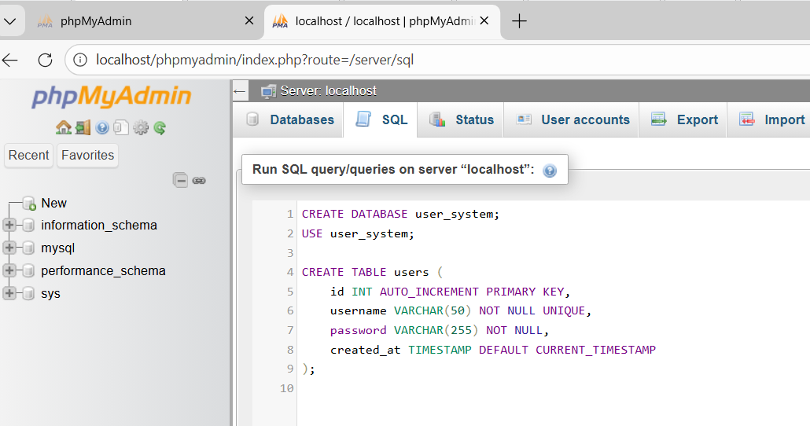

At the bottom of the page there is a Go button.

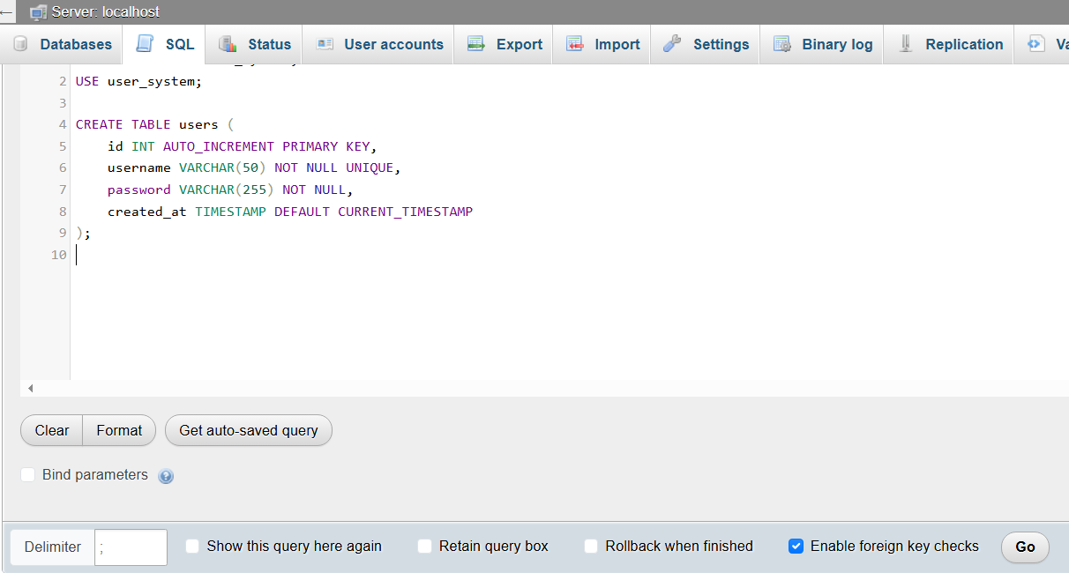

Click the Go button. This will create the required database and the table.

**Create a folder to upload the files.**

Go to the c:\inetpub\wwwroot directory. Create a new folder and name it as uploads.

Right click the uploads folder and then click properties.

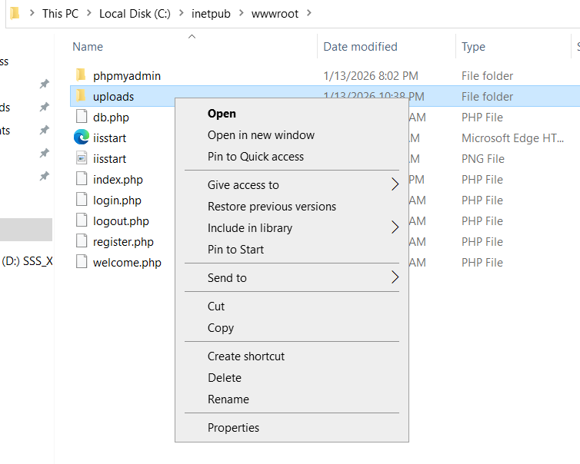

The following screen opens. Click Security tab.

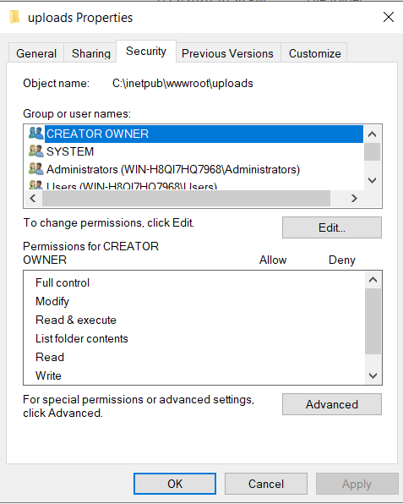

Click Edit button.

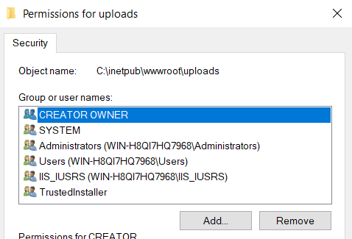

On the above Window click Add button.

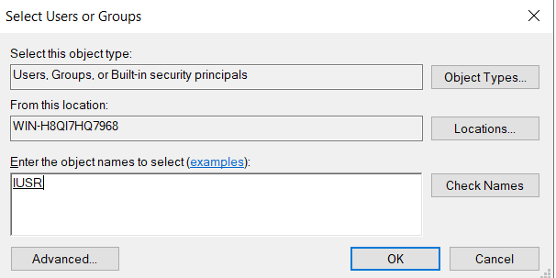

Type IUSR and click Check Names button. An underline will appear below IUSR as shown above. Click OK.

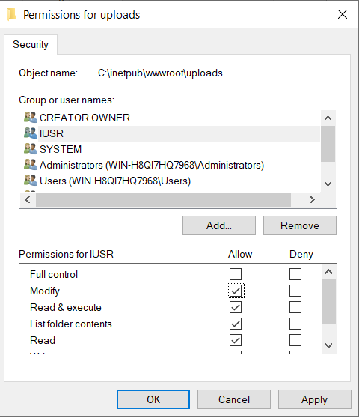

Select the IUSR name and below click the Modify check box to select it. It is as shown above. Click Apply and Click OK. Click OK to close all Windows.

**Verify file extensions of the PHP files.**

Go to the c:\inetpub\wwwroot directory.

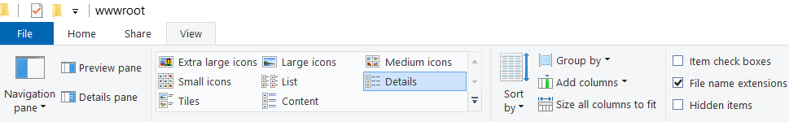

Click View tab. Then click the check box of the file name extensions on the right hand side as shown in the above image.

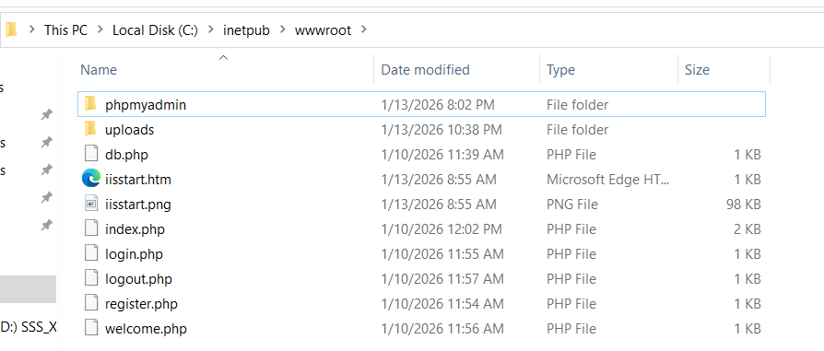

The extensions should be .php as shown above.

If the files show extensions as index.php.txt then rename the files to remove .txt from the file name.

Open the Application and test.

Open the browser and type <http://localhost> or <http://localhost/index.php>

The following web page should be displayed.

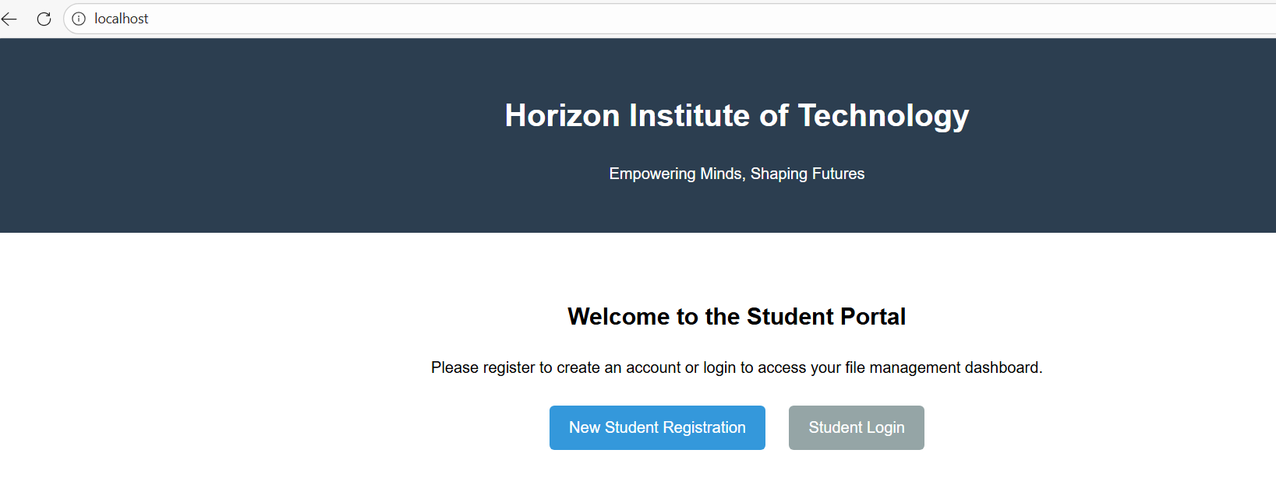

Now click New Student Registration page to create a new user. Try all the options.

If you get any error related to database then edit the db.php file and verify the username, password and database name.

This is how you have successfully deployed a PHP application using IIS web server.

**7. Secure the website by configuring https**

Even though the web application is running, it is not secure. This is because it is using http protocol. The http protocol transfers data in plain text between the client and the server. Thus if anyone is able to tap the data in between by performing a Man-In-The-Middle attack then the attacker will be able to get all usernames, passwords and the file data etc.

Thus to secure the web site you need to configure https. This requires creating a public key and private key (Certificates) for the web server.

For Internet hosted web sites you need to get the certificates from the authorized certification authorities. Here for this lab you will use a self signed certificate. This is useful for the LAN hosted web sites.

Login as administrator.

Make sure you have given some name to the computer. If not then provide a proper name to the computer.

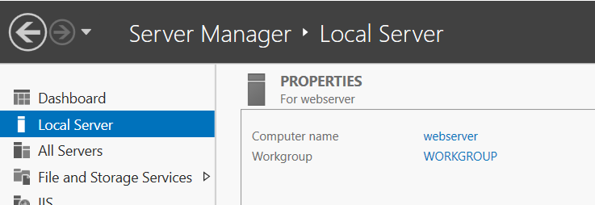

Open IIS Manager on the Web server. Click Tools.

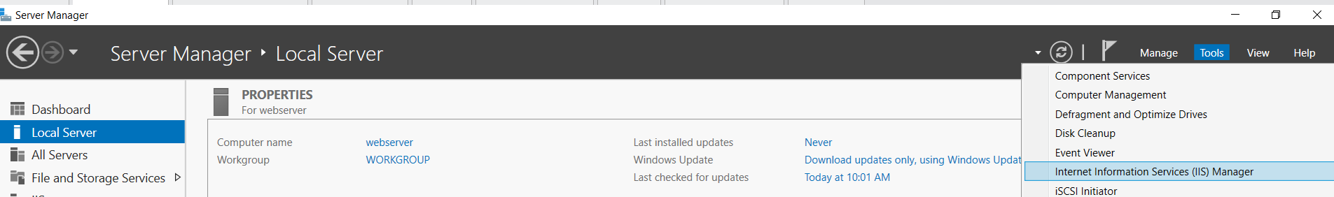

Click the server name in IIS manager and select Server Certificates as shown below.

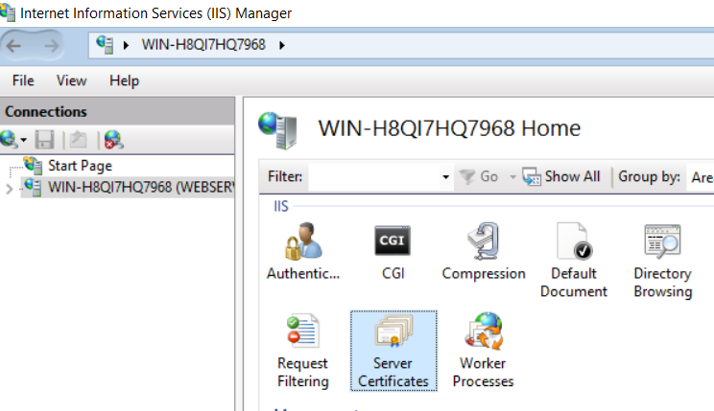

Double click Server Certificates.

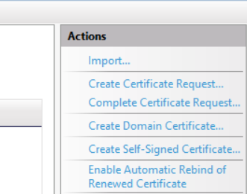

In the screen that is displayed, on the right hand side below Actions click **Create Self-Signed Certificate** option.

In the new window that opens type a name for this certificate and select Web Hosting option from the drop down as shown below.

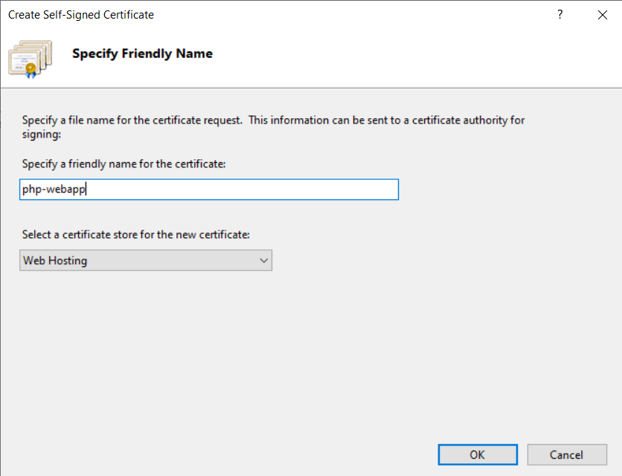

Click OK.

This will create a certificate as shown below.

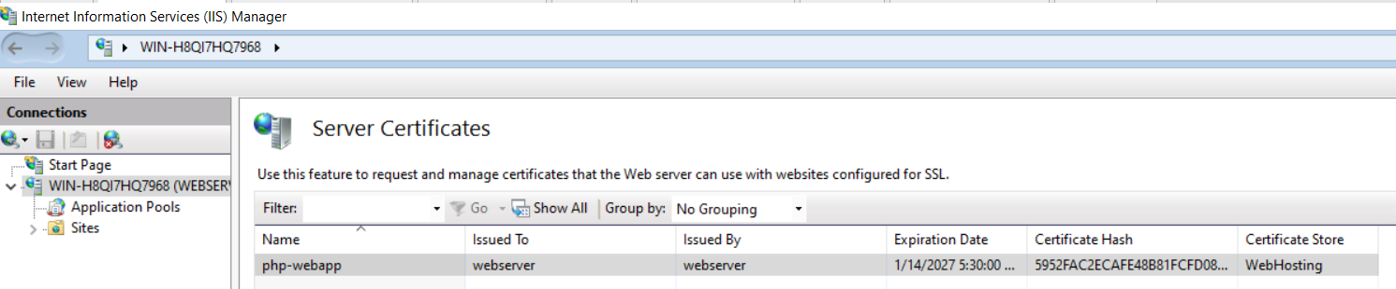

Select the certificate and double click on it.

In the window that opens, select details tab as shown below.

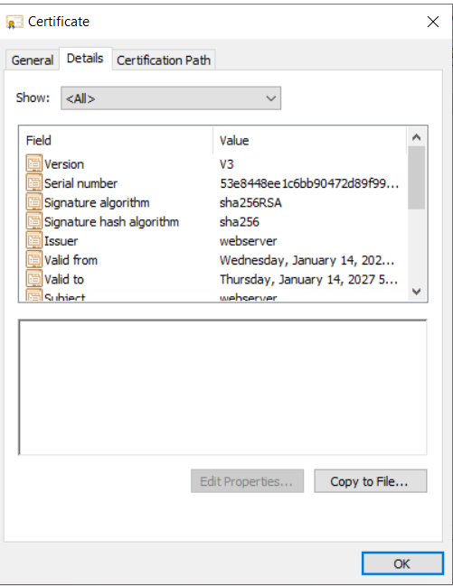

Then click Copy to File button at the bottom. Following wizard starts

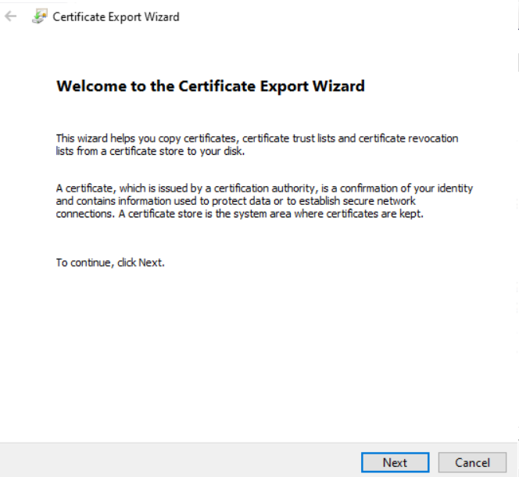

Click Next.

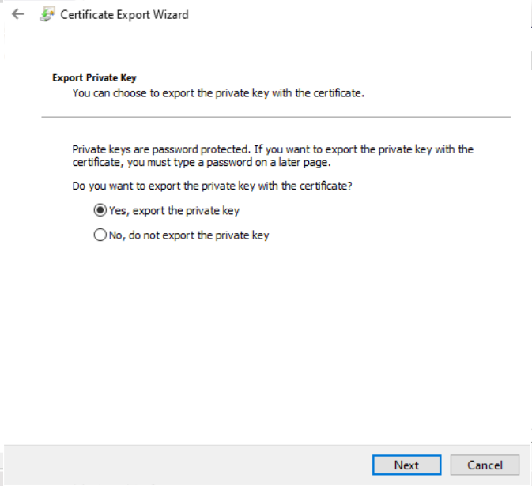

Select Yes, Export the private key. Click Next.

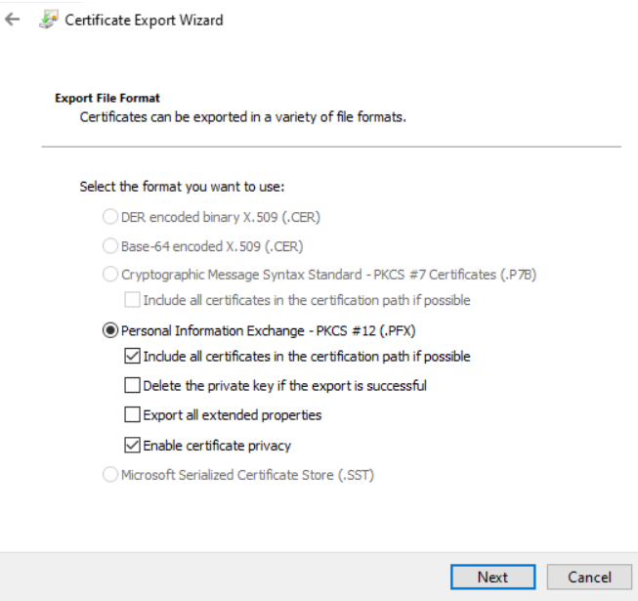

Keep default. Click Next.

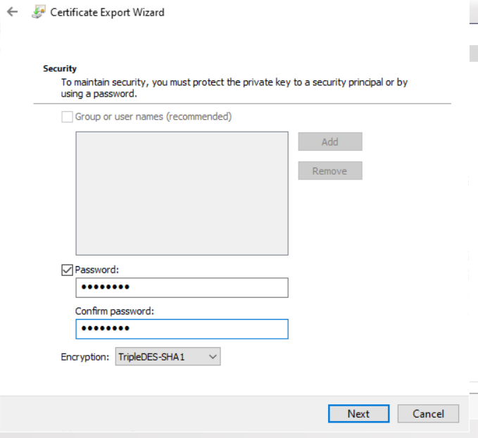

Select password check box. Type a password to protect private key. Click Next.

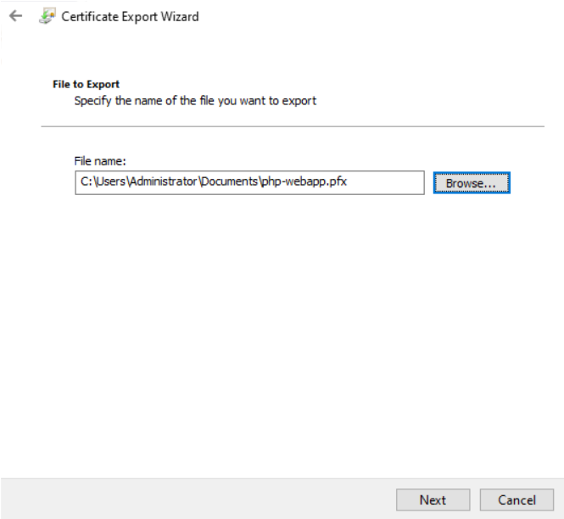

In the above window click browse and select a folder and provide a file name to store the private key. This is required in case if you format your web server and re create this web site. You can import this certificate again. Note down the password given as it may be required after 3 to 4 months.

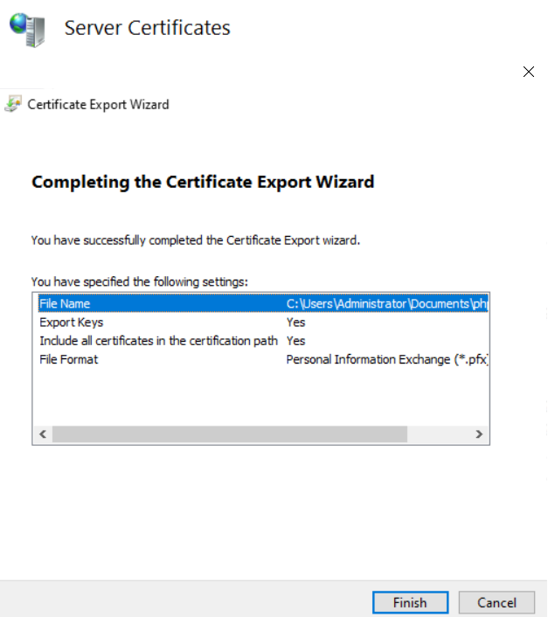

Click Finish.

This is how you have exported the private key of the web server. This key is very important and needs to be securely stored. This key should be with the web server only. Thus it is password protected. You need to copy it to backup device. Close all windows.

**Export the public key of the server.**

The process is almost same as above. Double click the certificate again. In the window that opens click Details tab as shown below.

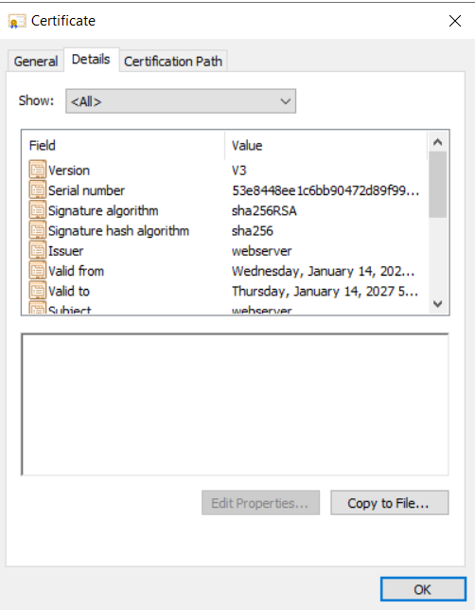

Click Copy to File button.

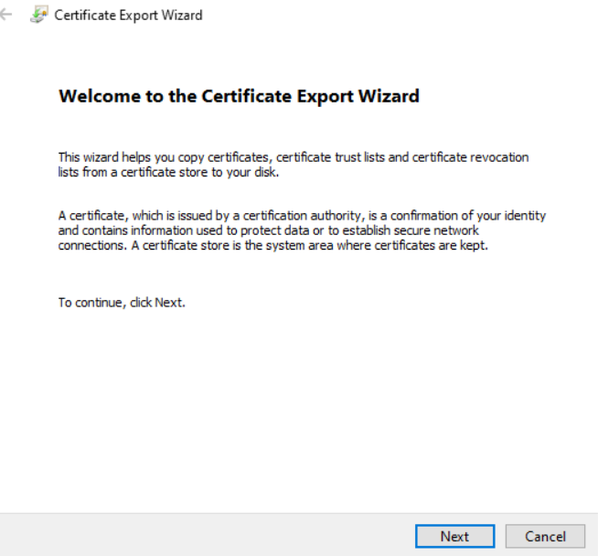

Click Next.

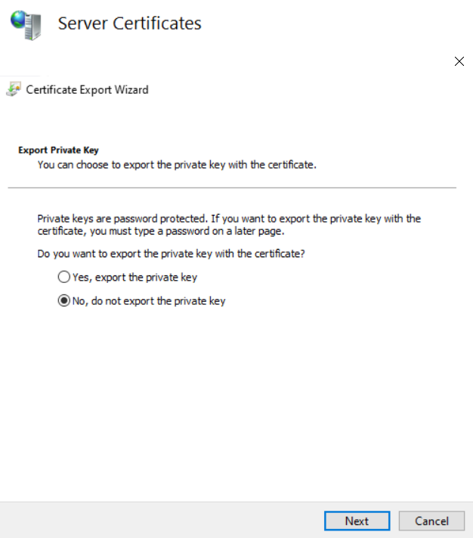

This time keep No, Do not export the private key option selected and click Next.

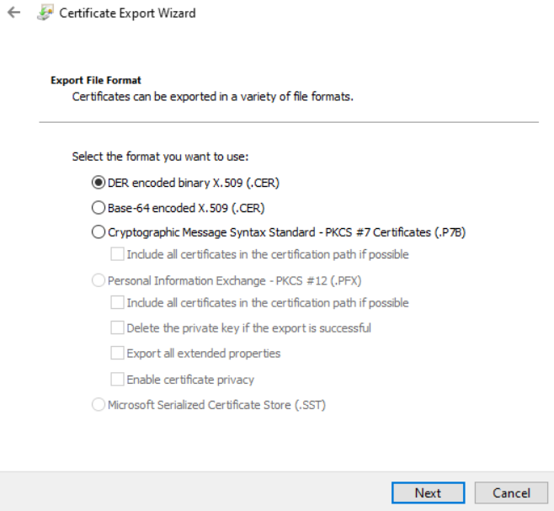

Click Next with the default options.

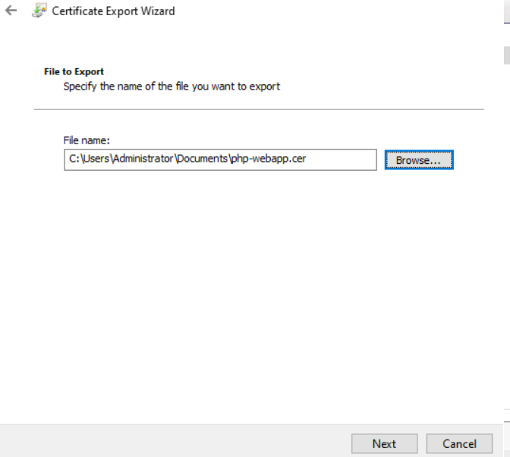

Click Browse button and select the same folder selected earlier for the private key file and give the same name. This time the extension of the file will be .cer.

Click Next. Click Finish. Close all the open Windows.

**Import Certificate to Client**

You need to perform this action on all the LAN computers which will access this website. If you have a Windows Domain then you can use the group policy to distribute this certificate.Else you can get a certificate from Windows Active directory certificate service installed in the domain.

Open Windows Run and type certmgr.msc

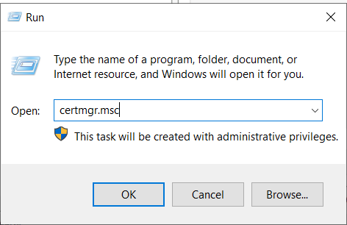

In the window that opens, select Trusted Root Certification Authority. Below that Certificate.

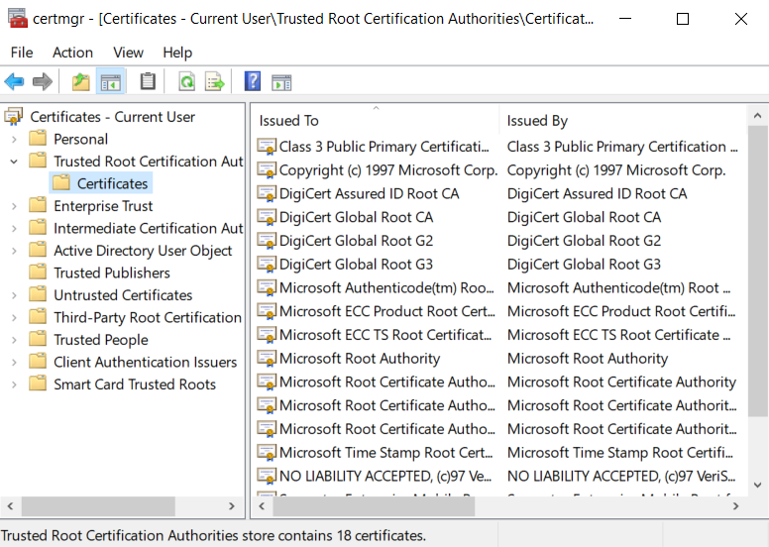

Right click the Certificate option. Select All Tasks and click Import as shown below.

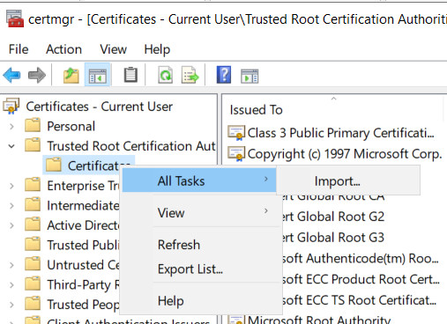

Click Next on the following window.

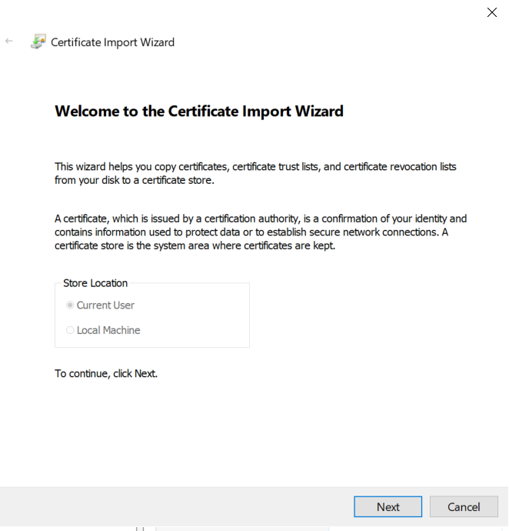

In the following window, Click Browse and select the folder where you exported the certificates in the above steps. Select .cer file.

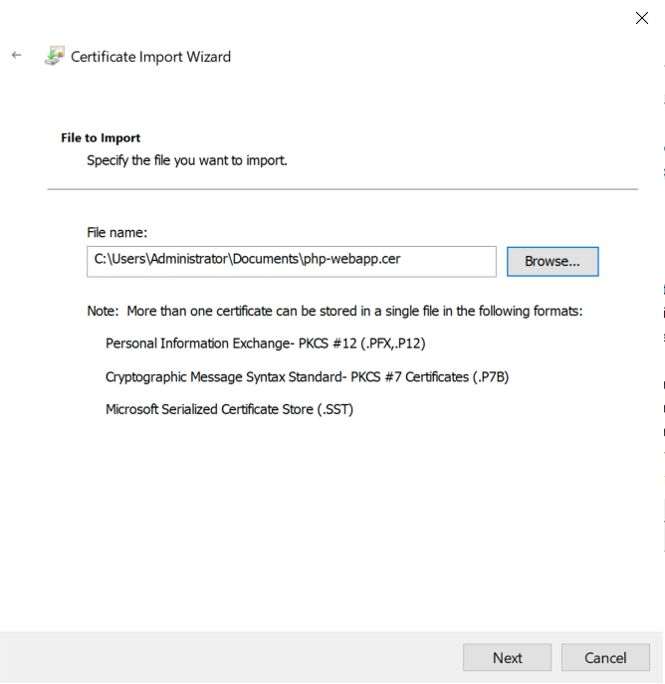

Click Next.

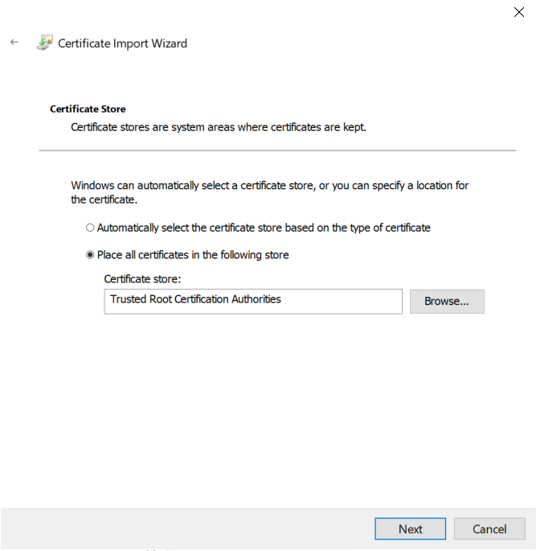

Make sure Trusted Root Certification Authorities is selected. Click Next.

Click Finish. Click OK to close all windows.

**Configure IIS for https**

Open IIS Manager from Tools in Server Manager.

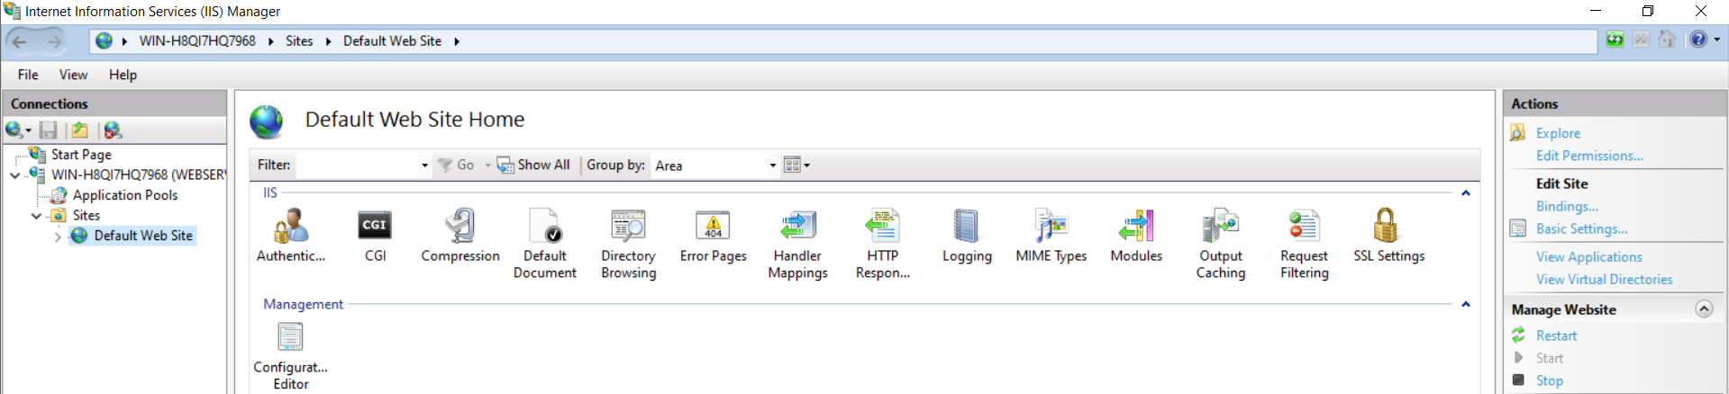

Expand sites option and select Default Web Site. On the right hand side below Edit Site option you will find bindings (Blue color) option. Click on it.

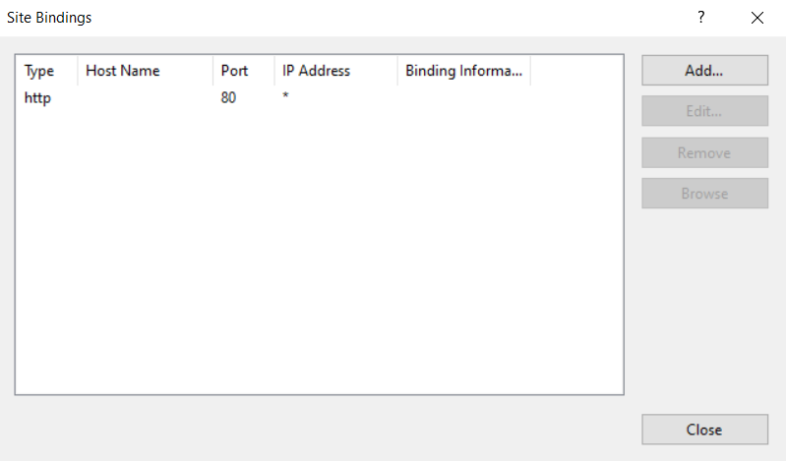

In the above Window click Add button.

In the window that opens, in the Type select https. In the SSL Certificate click drop down and select the certificate displayed.

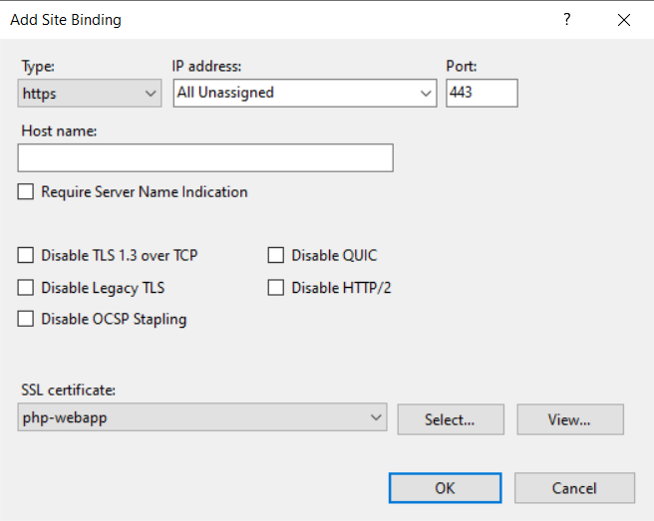

Click OK.

Now select http binding and click remove. Keep only https binding as shown below.

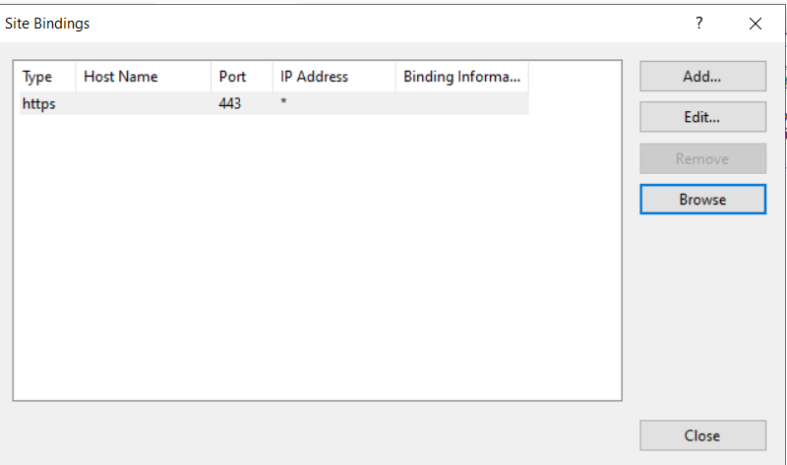

Click Close.

Now open the browser and type <https://name>ofyourserver

**The Website will open without any error. To provide name to the website like** [**www.webapp.lab**](http://www.webapp.lab) **you need to configure a certification authority server and a DNS server.**

**This is out of scope of this tutorial.**